**INTRODUCTION TO SOFTWARE ENGINEERING**

The term ***software engineering*** is composed of two words, software and engineering.

**Software** is more than just a program code. A program is an executable code, which serves some computational purpose. Software is considered to be a collection of executable programming code, associated libraries and documentations. Software, when made for a specific requirement is called **software product.**

**Engineering** on the other hand, is all about developing products, using well-defined, scientific principles and methods.

So, we can define ***software engineering*** as an engineering branch associated with the

development of software product using well-defined scientific principles, methods and

procedures. The outcome of software engineering is an efficient and reliable software product.

IEEE defines software engineering as:

*The application of a systematic, disciplined, quantifiable approach to the development, operation and maintenance of software.*

We can alternatively view it as a systematic collection of past experience. The experience is arranged in the form of methodologies and guidelines. A small program can be written without using software engineering principles. But if one wants to develop a large software product, then software engineering principles are absolutely necessary to achieve a good quality software cost effectively.

Without using software engineering principles it would be difficult to develop large programs. In industry it is usually needed to develop large programs to accommodate multiple functions. A problem with developing such large commercial programs is that the complexity and difficulty levels of the programs increase exponentially with their sizes. Software engineering helps to reduce this programming complexity. Software engineering principles use two important techniques to reduce problem complexity: ***abstraction*** and ***decomposition*.** The principle of abstraction implies that a problem can be simplified by omitting irrelevant details. In other words, the main purpose of abstraction is to consider only those aspects of the problem that are relevant for certain purpose and suppress other aspects that are not relevant for the given purpose. Once the simpler problem is solved, then the omitted details can be taken into consideration to solve the next lower level abstraction, and so on. Abstraction is a powerful way of reducing the complexity of the problem. The other approach to tackle problem complexity is

decomposition. In this technique, a complex problem is divided into several smaller problems and then the smaller problems are solved one by one. However, in this technique any random decomposition of a problem into smaller parts will not help. The problem has to be decomposed such that each component of the decomposed problem can be solved independently and then the solution of the different components can be combined to get the full solution. A good decomposition of a problem should minimize interactions among various components. If the different subcomponents are interrelated, then the different components cannot be solved separately and the desired reduction in complexity will not be realized.

### NEED OF SOFTWARE ENGINEERING

The need of software engineering arises because of higher rate of change in user requirements and environment on which the software is working.

* + **Large software -** It is easier to build a wall than to a house or building, likewise, as the size of software become large engineering has to step to give it a scientific process.
  + **Scalability-** If the software process were not based on scientific and engineering concepts, it would be easier to re-create new software than to scale an existing one.
  + **Cost-** As hardware industry has shown its skills and huge manufacturing has lower down the price of computer and electronic hardware. But the cost of software remains high if proper process is not adapted.
  + **Dynamic Nature-** The always growing and adapting nature of software hugely depends upon the environment in which the user works. If the nature of software is always changing, new enhancements need to be done in the existing one. This is where software engineering plays a good role.
  + **Quality Management-** Better process of software development provides better and quality software product.

### CHARACTERESTICS OF GOOD SOFTWARE

A software product can be judged by what it offers and how well it can be used. This software must satisfy on the following grounds:

* + Operational
  + Transitional
  + Maintenance

Well-engineered and crafted software is expected to have the following characteristics:

### Operational

This tells us how well software works in operations. It can be measured on:

* + Budget
  + Usability
  + Efficiency
  + Correctness
  + Functionality
  + Dependability
  + Security
  + Safety

### Transitional

This aspect is important when the software is moved from one platform to another:

* + Portability
  + Interoperability
  + Reusability
  + Adaptability

### Maintenance

This aspect briefs about how well a software has the capabilities to maintain itself in the ever- changing environment:

* + Modularity
  + Maintainability
  + Flexibility
  + Scalability

In short, Software engineering is a branch of computer science, which uses well-defined engineering concepts required to produce efficient, durable, scalable, in-budget and on-time software products

**SOFTWARE DEVELOPMENT LIFE CYCLE**

### LIFE CYCLE MODEL

A software life cycle model (also called process model) is a descriptive and diagrammatic representation of the software life cycle. A life cycle model represents all the activities required to make a software product transit through its life cycle phases. It also captures the order in which these activities are to be undertaken. In other words, a life cycle model maps the different activities performed on a software product from its inception to retirement. Different life cycle models may map the basic development activities to phases in different ways. Thus, no matter which life cycle model is followed, the basic activities are included in all life cycle models though the activities may be carried out in different orders in different life cycle models. During any life cycle phase, more than one activity may also be carried out.

**THE NEED FOR A SOFTWARE LIFE CYCLE MODEL**

The development team must identify a suitable life cycle model for the particular project and then adhere to it. Without using of a particular life cycle model the development of a software product would not be in a systematic and disciplined manner. When a software product is being developed by a team there must be a clear understanding among team members about when and what to do. Otherwise it would lead to chaos and project failure. This problem can be illustrated by using an example. Suppose a software development problem is divided into several parts and the parts are assigned to the team members. From then on, suppose the team members are allowed the freedom to develop the parts assigned to them in whatever way they like. It is possible that one member might start writing the code for his part, another might decide to prepare the test documents first, and some other engineer might begin with the design phase of the parts assigned to him. This would be one of the perfect recipes for project failure. A software life cycle model defines entry and exit criteria for every phase. A phase can start only if its phase-entry criteria have been satisfied. So without software life cycle model the entry and exit criteria for a phase cannot be recognized. Without software life cycle models it becomes difficult for software project managers to monitor the progress of the project.

#### Different software life cycle models

Many life cycle models have been proposed so far. Each of them has some advantages as well as some disadvantages. A few important and commonly used life cycle models are as follows:

* + - Classical Waterfall Model
    - Iterative Waterfall Model
    - Prototyping Model
    - Evolutionary Model
    - Spiral Model

### CLASSICAL WATERFALL MODEL

The classical waterfall model is intuitively the most obvious way to develop software. Though the classical waterfall model is elegant and intuitively obvious, it is not a practical model in the sense that it cannot be used in actual software development projects. Thus, this model can be considered to be a *theoretical way of developing software*. But all other life cycle models are essentially derived from the classical waterfall model. So, in order to be able to appreciate other life cycle models it is necessary to learn the classical waterfall model. Classical waterfall model divides the life cycle into the following phases as shown in fig.2.1:

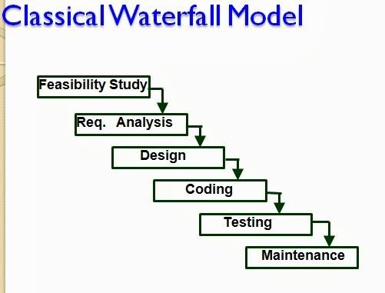

Fig 2.1: Classical Waterfall Model

**Feasibility study** - The main aim of feasibility study is to determine whether it would be financially and technically feasible to develop the product.

* + At first project managers or team leaders try to have a rough understanding of what is required to be done by visiting the client side. They study different input data to the system and output data to be produced by the system. They study what kind of processing is needed to be done on these data and they look at the various constraints on the behavior of the system.
  + After they have an overall understanding of the problem they investigate the different solutions that are possible. Then they examine each of the solutions in terms of what kind of resources required, what would be the cost of development and what would be the development time for each solution.
  + Based on this analysis they pick the best solution and determine whether the solution is feasible financially and technically. They check whether the customer budget would meet the cost of the product and whether they have sufficient technical expertise in the area of development.

**Requirements analysis and specification: -** The aim of the requirements analysis and specification phase is to understand the exact requirements of the customer and to document them properly. This phase consists of two distinct activities, namely

* + - Requirements gathering and analysis
    - Requirements specification

The goal of the requirements gathering activity is to collect all relevant information from the customer regarding the product to be developed. This is done to clearly understand the customer requirements so that incompleteness and inconsistencies are removed.

The requirements analysis activity is begun by collecting all relevant data regarding the product to be developed from the users of the product and from the customer through interviews and discussions. For example, to perform the requirements analysis of a business accounting software required by an organization, the analyst might interview all the accountants of the organization to ascertain their requirements. The data collected from such a group of users usually contain several contradictions and ambiguities, since each user typically has only a partial and incomplete view of the system. Therefore it is necessary to identify all ambiguities and contradictions in the requirements and resolve them through further discussions with the customer. After all ambiguities, inconsistencies, and incompleteness have been resolved and all the requirements properly understood, the requirements specification activity can start. During this activity, the user requirements are systematically organized into a Software Requirements Specification (SRS) document. The customer requirements identified during the requirements gathering and analysis activity are organized into a SRS document. The important components of this document are functional requirements, the nonfunctional requirements, and the goals of implementation.

**Design: -** The goal of the design phase is to transform the requirements specified in the SRS document into a structure that is suitable for implementation in some programming language. In technical terms, during the design phase the software architecture is derived from the SRS document. Two distinctly different approaches are available: the traditional design approach and the object-oriented design approach.

* + **Traditional design approach -**Traditional design consists of two different activities; first a structured analysis of the requirements specification is carried out where the detailed structure of the problem is examined. This is followed by a structured design activity. During structured design, the results of structured analysis are transformed into the software design.
  + **Object-oriented design approach** -In this technique, various objects that occur in the problem domain and the solution domain are first identified, and the different relationships that exist among these objects are identified. The object structure is further refined to obtain the detailed design.

**Coding and unit testing:-**The purpose of the coding phase (sometimes called the implementation phase) of software development is to translate the software design into source code. Each component of the design is implemented as a program module. The end-product of this phase is a set of program modules that have been individually tested. During this phase, each module is unit tested to determine the correct working of all the individual modules. It involves testing each module in isolation as this is the most efficient way to debug the errors identified at this stage.

**Integration and system testing: -**Integration of different modules is undertaken once they have been coded and unit tested. During the integration and system testing phase, the modules are integrated in a planned manner. The different modules making up a software product are almost never integrated in one shot. Integration is normally carried out incrementally over a number of steps. During each integration step, the partially integrated system is tested and a set of previously planned modules are added to it. Finally, when all the modules have been successfully integrated and tested, system testing is carried out. The goal of system testing is to ensure that the developed system conforms to its requirements laid out in the SRS document. System testing usually consists of three different kinds of testing activities:

* + α – testing: It is the system testing performed by the development team.
  + β –testing: It is the system testing performed by a friendly set of customers.
  + Acceptance testing: It is the system testing performed by the customer himself after the product delivery to determine whether to accept or reject the delivered product.

System testing is normally carried out in a planned manner according to the system test plan document. The system test plan identifies all testing-related activities that must be performed,

specifies the schedule of testing, and allocates resources. It also lists all the test cases and the expected outputs for each test case.

**Maintenance: -**Maintenance of a typical software product requires much more than the effort necessary to develop the product itself. Many studies carried out in the past confirm this and indicate that the relative effort of development of a typical software product to its maintenance effort is roughly in the 40:60 ratios. Maintenance involves performing any one or more of the following three kinds of activities:

* + Correcting errors that were not discovered during the product development phase. This is called corrective maintenance.
  + Improving the implementation of the system, and enhancing the functionalities of the system according to the customer’s requirements. This is called perfective maintenance.
  + Porting the software to work in a new environment. For example, porting may be required to get the software to work on a new computer platform or with a new operating system. This is called adaptive maintenance.

#### Shortcomings of the classical waterfall model

The classical waterfall model is an idealistic one since it assumes that no development error is ever committed by the engineers during any of the life cycle phases. However, in practical development environments, the engineers do commit a large number of errors in almost every phase of the life cycle. The source of the defects can be many: oversight, wrong assumptions, use of inappropriate technology, communication gap among the project engineers, etc. These defects usually get detected much later in the life cycle. For example, a design defect might go unnoticed till we reach the coding or testing phase. Once a defect is detected, the engineers need to go back to the phase where the defect had occurred and redo some of the work done during that phase and the subsequent phases to correct the defect and its effect on the later phases. Therefore, in any practical software development work, it is not possible to strictly follow the classical waterfall model.

### ITERATIVE WATERFALL MODEL

To overcome the major shortcomings of the classical waterfall model, we come up with the iterative waterfall model.

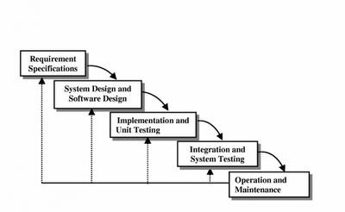

Fig 3.1 : Iterative Waterfall Model

Here, we provide feedback paths for error correction as & when detected later in a phase. Though errors are inevitable, but it is desirable to detect them in the same phase in which they occur. If so, this can reduce the effort to correct the bug.

The advantage of this model is that there is a working model of the system at a very early stage of development which makes it easier to find functional or design flaws. Finding issues at an early stage of development enables to take corrective measures in a limited budget.

The disadvantage with this SDLC model is that it is applicable only to large and bulky software development projects. This is because it is hard to break a small software system into further small serviceable increments/modules.

### PRTOTYPING MODEL Prototype

A prototype is a toy implementation of the system. A prototype usually exhibits limited functional capabilities, low reliability, and inefficient performance compared to the actual software. A prototype is usually built using several shortcuts. The shortcuts might involve using inefficient, inaccurate, or dummy functions. The shortcut implementation of a function, for example, may produce the desired results by using a table look-up instead of performing the actual computations. A prototype usually turns out to be a very crude version of the actual system.

#### Need for a prototype in software development

There are several uses of a prototype. An important purpose is to illustrate the input data formats, messages, reports, and the interactive dialogues to the customer. This is a valuable mechanism for gaining better understanding of the customer’s needs:

* + how the screens might look like
  + how the user interface would behave
  + how the system would produce outputs

Another reason for developing a prototype is that it is impossible to get the perfect product in the first attempt. Many researchers and engineers advocate that if you want to develop a good product you must plan to throw away the first version. The experience gained in developing the prototype can be used to develop the final product.

A prototyping model can be used when technical solutions are unclear to the development team. A developed prototype can help engineers to critically examine the technical issues associated with the product development. Often, major design decisions depend on issues like the response time of a hardware controller, or the efficiency of a sorting algorithm, etc. In such circumstances, a prototype may be the best or the only way to resolve the technical issues.

A prototype of the actual product is preferred in situations such as:

* User requirements are not complete
* Technical issues are not clear

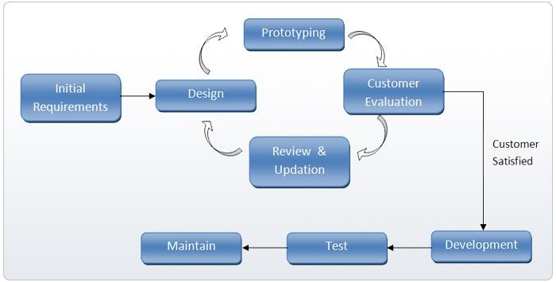

Fig 3.2: Prototype Model

### EVOLUTIONARY MODEL

It is also called *successive versions model* or *incremental model*. At first, a simple working model is built. Subsequently it undergoes functional improvements & we keep on adding new functions till the desired system is built.

Applications:

* + Large projects where you can easily find modules for incremental implementation. Often used when the customer wants to start using the core features rather than waiting for the full software.
  + Also used in object oriented software development because the system can be easily portioned into units in terms of objects.

Advantages:

* + User gets a chance to experiment partially developed system
  + Reduce the error because the core modules get tested thoroughly. Disadvantages:
  + It is difficult to divide the problem into several versions that would be acceptable to the customer which can be incrementally implemented & delivered.

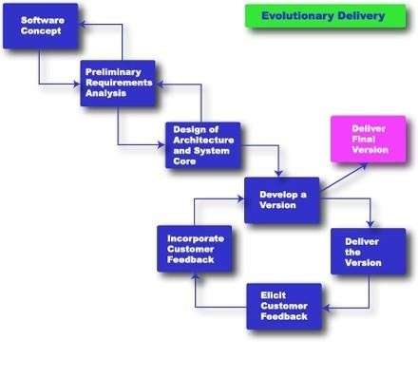

Fig 3.3: Evolutionary Model

### SPIRAL MODEL

The Spiral model of software development is shown in fig. 4.1. The diagrammatic representation of this model appears like a spiral with many loops. The exact number of loops in the spiral is not fixed. Each loop of the spiral represents a phase of the software process. For example, the innermost loop might be concerned with feasibility study, the next loop with requirements specification, the next one with design, and so on. Each phase in this model is split into four sectors (or quadrants) as shown in fig. 4.1. The following activities are carried out during each phase of a spiral model.

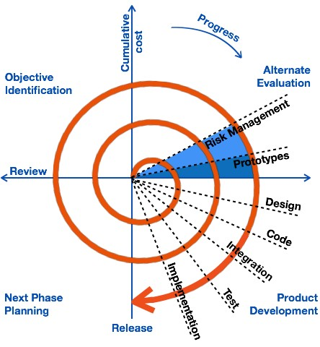

Fig 4.1: Spiral Model

### First quadrant (Objective Setting)

* During the first quadrant, it is needed to identify the objectives of the phase.
* Examine the risks associated with these objectives.

### Second Quadrant (Risk Assessment and Reduction)

* A detailed analysis is carried out for each identified project risk.
* Steps are taken to reduce the risks. For example, if there is a risk that the requirements are inappropriate, a prototype system may be developed.

### Third Quadrant (Development and Validation)

* + Develop and validate the next level of the product after resolving the identified risks.

### Fourth Quadrant (Review and Planning)

* + Review the results achieved so far with the customer and plan the next iteration around the spiral.
  + Progressively more complete version of the software gets built with each iteration around the spiral.

#### Circumstances to use spiral model

The spiral model is called a meta model since it encompasses all other life cycle models. Risk handling is inherently built into this model. The spiral model is suitable for development of technically challenging software products that are prone to several kinds of risks. However, this model is much more complex than the other models – this is probably a factor deterring its use in ordinary projects.

#### Comparison of different life-cycle models

The classical waterfall model can be considered as the basic model and all other life cycle models as embellishments of this model. However, the classical waterfall model cannot be used in practical development projects, since this model supports no mechanism to handle the errors committed during any of the phases.

This problem is overcome in the iterative waterfall model. The iterative waterfall model is probably the most widely used software development model evolved so far. This model is simple to understand and use. However this model is suitable only for well-understood problems; it is not suitable for very large projects and for projects that are subject to many risks.

The prototyping model is suitable for projects for which either the user requirements or the underlying technical aspects are not well understood. This model is especially popular for development of the user-interface part of the projects.

The evolutionary approach is suitable for large problems which can be decomposed into a set of modules for incremental development and delivery. This model is also widely used for object- oriented development projects. Of course, this model can only be used if the incremental delivery of the system is acceptable to the customer.

The spiral model is called a meta model since it encompasses all other life cycle models. Risk handling is inherently built into this model. The spiral model is suitable for development of technically challenging software products that are prone to several kinds of risks. However, this model is much more complex than the other models – this is probably a factor deterring its use in ordinary projects.

The different software life cycle models can be compared from the viewpoint of the customer. Initially, customer confidence in the development team is usually high irrespective of the development model followed. During the lengthy development process, customer confidence normally drops off, as no working product is immediately visible. Developers answer customer queries using technical slang, and delays are announced. This gives rise to customer resentment. On the other hand, an evolutionary approach lets the customer experiment with a working product much earlier than the monolithic approaches. Another important advantage of the incremental model is that it reduces the customer’s trauma of getting used to an entirely new system. The gradual introduction of the product via incremental phases provides time to the customer to adjust to the new product. Also, from the customer’s financial viewpoint, incremental development does not require a large upfront capital outlay. The customer can order the incremental versions as and when he can afford them.

**REQUIREMENTS ANALYSIS AND SPECIFICATION**

Before we start to develop our software, it becomes quite essential for us to understand and document the exact requirement of the customer. Experienced members of the development team carry out this job. They are called as ***system analysts***.

The analyst starts *requirements gathering and analysis* activity by collecting all information from the customer which could be used to develop the requirements of the system. He then analyzes the collected information to obtain a clear and thorough understanding of the product to be developed, with a view to remove all ambiguities and inconsistencies from the initial customer perception of the problem. The following basic questions pertaining to the project should be clearly understood by the analyst in order to obtain a good grasp of the problem:

* What is the problem?
* Why is it important to solve the problem?
* What are the possible solutions to the problem?
* What exactly are the data input to the system and what exactly are the data output by the system?
* What are the likely complexities that might arise while solving the problem?
* If there are external software or hardware with which the developed software has to interface, then what exactly would the data interchange formats with the external system be?

After the analyst has understood the exact customer requirements, he proceeds to identify and resolve the various requirements problems. The most important requirements problems that the analyst has to identify and eliminate are the problems of anomalies, inconsistencies, and incompleteness. When the analyst detects any inconsistencies, anomalies or incompleteness in the gathered requirements, he resolves them by carrying out further discussions with the end- users and the customers.

Parts of a SRS document

* The important parts of SRS document are: Functional requirements of the system

Non-functional requirements of the system, and

Goals of implementation

### Functional requirements:-

The functional requirements part discusses the functionalities required from the system. The system is considered to perform a set of high-level functions {*f* }. The functional view of the

*i*

system is shown in fig. 5.1. Each function f of the system can be considered as a transformation

i

of a set of input data (ii) to the corresponding set of output data (*o* ). The user can get some

*i*

meaningful piece of work done using a high-level function.

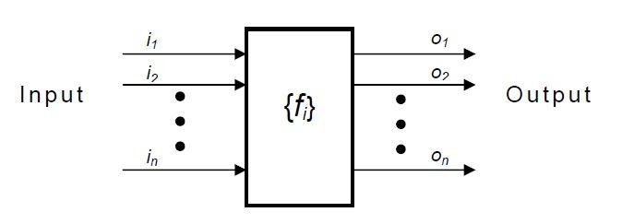

Fig. 5.1: View of a system performing a set of functions

### Nonfunctional requirements:-

Nonfunctional requirements deal with the characteristics of the system which cannot be expressed as functions - such as the maintainability of the system, portability of the system, usability of the system, etc.

### Goals of implementation:-

The goals of implementation part documents some general suggestions regarding development. These suggestions guide trade-off among design goals. The goals of implementation section might document issues such as revisions to the system functionalities that may be required in the future, new devices to be supported in the future, reusability issues, etc. These are the items which the developers might keep in their mind during development so that the developed system may meet some aspects that are not required immediately.

#### Identifying functional requirements from a problem description

The high-level functional requirements often need to be identified either from an informal problem description document or from a conceptual understanding of the problem. Each high- level requirement characterizes a way of system usage by some user to perform some meaningful piece of work. There can be many types of users of a system and their requirements from the system may be very different. So, it is often useful to identify the different types of users who might use the system and then try to identify the requirements from each user’s perspective.

**Example: -** Consider the case of the library system, where **– F1:** Search Book function

**Input:** an author’s name

**Output:** details of the author’s books and the location of these books in the library

So the function Search Book (F1) takes the author's name and transforms it into book details.

Functional requirements actually describe a set of high-level requirements, where each high-level requirement takes some data from the user and provides some data to the user as an output. Also each high-level requirement might consist of several other functions.

#### Documenting functional requirements

For documenting the functional requirements, we need to specify the set of functionalities supported by the system. A function can be specified by identifying the state at which the data is to be input to the system, its input data domain, the output data domain, and the type of processing to be carried on the input data to obtain the output data. Let us first try to document the withdraw-cash function of an ATM (Automated Teller Machine) system. The withdraw-cash is a high-level requirement. It has several sub-requirements corresponding to the different user interactions. These different interaction sequences capture the different scenarios.

**Example: -** Withdraw Cash from ATM R1: withdraw cash

Description: The withdraw cash function first determines the type of account that the user has and the account number from which the user wishes to withdraw cash. It checks the balance to determine whether the requested amount is available in the account. If enough balance is available, it outputs the required cash; otherwise it generates an error message.

R1.1 select withdraw amount option Input: “withdraw amount” option

Output: user prompted to enter the account type R1.2: select account type

Input: user option

Output: prompt to enter amount R1.3: get required amount

Input: amount to be withdrawn in integer values greater than 100 and less than 10,000 in multiples of 100.

Output: The requested cash and printed transaction statement.

Processing: the amount is debited from the user’s account if sufficient balance is available, otherwise an error message displayed

#### Properties of a good SRS document

The important properties of a good SRS document are the following:

* + **Concise.** The SRS document should be concise and at the same time unambiguous, consistent, and complete. Verbose and irrelevant descriptions reduce readability and also increase error possibilities.
  + **Structured.** It should be well-structured. A well-structured document is easy to understand and modify. In practice, the SRS document undergoes several revisions to cope up with the customer requirements. Often, the customer requirements evolve over a period of time. Therefore, in order to make the modifications to the SRS document easy, it is important to make the document well-structured.
  + **Black-box view.** It should only specify what the system should do and refrain from stating how to do these. This means that the SRS document should specify the external behavior of the system and not discuss the implementation issues. The SRS document should view the system to be developed as black box, and should specify the externally visible behavior of the system. For this reason, the SRS document is also called the black-box specification of a system.
  + **Conceptual integrity.** It should show conceptual integrity so that the reader can easily understand it.
  + **Response to undesired events.** It should characterize acceptable responses to undesired events. These are called system response to exceptional conditions.
  + **Verifiable.** All requirements of the system as documented in the SRS document should be verifiable. This means that it should be possible to determine whether or not requirements have been met in an implementation.

#### Problems without a SRS document

The important problems that an organization would face if it does not develop a SRS document are as follows:

* + Without developing the SRS document, the system would not be implemented according to customer needs.
  + Software developers would not know whether what they are developing is what exactly required by the customer.
  + Without SRS document, it will be very much difficult for the maintenance engineers to understand the functionality of the system.
  + It will be very much difficult for user document writers to write the users’ manuals properly without understanding the SRS document.

#### Problems with an unstructured specification

* It would be very much difficult to understand that document.
* It would be very much difficult to modify that document.
* Conceptual integrity in that document would not be shown.
* The SRS document might be unambiguous and inconsistent.

**SOFTWARE DESIGN**

Software design is a process to transform user requirements into some suitable form, which helps the programmer in software coding and implementation.

For assessing user requirements, an SRS (Software Requirement Specification) document is created whereas for coding and implementation, there is a need of more specific and detailed requirements in software terms. The output of this process can directly be used into implementation in programming languages.

Software design is the first step in SDLC (Software Design Life Cycle), which moves the concentration from problem domain to solution domain. It tries to specify how to fulfill the requirements mentioned in SRS.

Software Design Levels

Software design yields three levels of results:

* **Architectural Design -** The architectural design is the highest abstract version of the system. It identifies the software as a system with many components interacting with each other. At this level, the designers get the idea of proposed solution domain.
* **High-level Design-** The high-level design breaks the ‘single entity-multiple component’ concept of architectural design into less-abstracted view of sub-systems and modules and depicts their interaction with each other. High-level design focuses on how the system along with all of its components can be implemented in forms of modules. It recognizes modular structure of each sub-system and their relation and interaction among each other.
* **Detailed Design-** Detailed design deals with the implementation part of what is seen as a system and its sub-systems in the previous two designs. It is more detailed towards modules and their implementations. It defines logical structure of each module and their interfaces to communicate with other modules.

### Modularization

Modularization is a technique to divide a software system into multiple discrete and independent modules, which are expected to be capable of carrying out task(s) independently. These modules may work as basic constructs for the entire software. Designers tend to design modules such that they can be executed and/or compiled separately and independently.

Modular design unintentionally follows the rules of ‘divide and conquer’ problem-solving strategy this is because there are many other benefits attached with the modular design of a software.

Advantage of modularization:

* Smaller components are easier to maintain
* Program can be divided based on functional aspects
* Desired level of abstraction ca n be brought in the program
* Components with high cohesion can be re-used again.
* Concurrent execution can be made possible
* Desired from security aspect

### Concurrency

Back in time, all softwares were meant to be executed sequentially. By sequential execution we mean that the coded instruction will be executed one after another implying only one portion of program being activated at any given time. Say, a software has multiple modules, then only one of all the modules can be found active at any time of execution.

In software design, concurrency is implemented by splitting the software into multiple independent units of execution, like modules and executing them in parallel. In other words, concurrency provides capability to the software to execute more than one part of code in parallel to each other.

It is necessary for the programmers and designers to recognize those modules, which can be made parallel execution.

Example

The spell check feature in word processor is a module of software, which runs alongside the word processor itself.

### Coupling and Cohesion

When a software program is modularized, its tasks are divided into several modules based on some characteristics. As we know, modules are set of instructions put together in order to achieve some tasks. They are though, considered as single entity but may refer to each other to work together. There are measures by which the quality of a design of modules and their interaction among them can be measured. These measures are called coupling and cohesion.

### Cohesion

Cohesion is a measure that defines the degree of intra-dependability within elements of a module. The greater the cohesion, the better is the program design.

There are seven types of cohesion, namely –

* **Co-incidental cohesion -** It is unplanned and random cohesion, which might be the result of breaking the program into smaller modules for the sake of modularization. Because it is unplanned, it may serve confusion to the programmers and is generally not-accepted.
* **Logical cohesion -** When logically categorized elements are put together into a module, it is called logical cohesion.
* **Temporal Cohesion -** When elements of module are organized such that they are processed at a similar point in time, it is called temporal cohesion.
* **Procedural cohesion -** When elements of module are grouped together, which are executed sequentially in order to perform a task, it is called procedural cohesion.
* **Communicational cohesion -** When elements of module are grouped together, which are executed sequentially and work on same data (information), it is called communicational cohesion.
* **Sequential cohesion -** When elements of module are grouped because the output of one element serves as input to another and so on, it is called sequential cohesion.
* **Functional cohesion -** It is considered to be the highest degree of cohesion, and it is highly expected. Elements of module in functional cohesion are grouped because they all contribute to a single well-defined function. It can also be reused.

### Coupling

Coupling is a measure that defines the level of inter-dependability among modules of a program. It tells at what level the modules interfere and interact with each other. The lower the coupling, the better the program.

There are five levels of coupling, namely -

* **Content coupling -** When a module can directly access or modify or refer to the content of another module, it is called content level coupling.
* **Common coupling-** When multiple modules have read and write access to some global data, it is called common or global coupling.
* **Control coupling-** Two modules are called control-coupled if one of them decides the function of the other module or changes its flow of execution.
* **Stamp coupling-** When multiple modules share common data structure and work on different part of it, it is called stamp coupling.
* **Data coupling-** Data coupling is when two modules interact with each other by means of passing data (as parameter). If a module passes data structure as parameter, then the receiving module should use all its components.

Ideally, no coupling is considered to be the best.

### Design Verification

The output of software design process is design documentation, pseudo codes, detailed logic diagrams, process diagrams, and detailed description of all functional or non-functional requirements.

The next phase, which is the implementation of software, depends on all outputs mentioned above.

It is then becomes necessary to verify the output before proceeding to the next phase. The early any mistake is detected, the better it is or it might not be detected until testing of the product. If the outputs of design phase are in formal notation form, then their associated tools for verification should be used otherwise a thorough design review can be used for verification and validation.

By structured verification approach, reviewers can detect defects that might be caused by overlooking some conditions. A good design review is important for good software design, accuracy and quality.

**SOFTWARE DESIGN STRATEGIES**

Software design is a process to conceptualize the software requirements into software implementation. Software design takes the user requirements as challenges and tries to find optimum solution. While the software is being conceptualized, a plan is chalked out to find the best possible design for implementing the intended solution.

There are multiple variants of software design. Let us study them briefly:

Software design is a process to conceptualize the software requirements into software implementation. Software design takes the user requirements as challenges and tries to find optimum solution. While the software is being conceptualized, a plan is chalked out to find the best possible design for implementing the intended solution.

There are multiple variants of software design. Let us study them briefly:

### Structured Design

Structured design is a conceptualization of problem into several well-organized elements of solution. It is basically concerned with the solution design. Benefit of structured design is, it gives better understanding of how the problem is being solved. Structured design also makes it simpler for designer to concentrate on the problem more accurately.

Structured design is mostly based on ‘divide and conquer’ strategy where a problem is broken into several small problems and each small problem is individually solved until the whole problem is solved.

The small pieces of problem are solved by means of solution modules. Structured design emphasis that these modules be well organized in order to achieve precise solution.

These modules are arranged in hierarchy. They communicate with each other. A good structured design always follows some rules for communication among multiple modules, namely -

**Cohesion** - grouping of all functionally related elements.

**Coupling** - communication between different modules.

A good structured design has ***high*** cohesion and ***low*** coupling arrangements.

### Function Oriented Design

In function-oriented design, the system is comprised of many smaller sub-systems known as functions. These functions are capable of performing significant task in the system. The system is considered as top view of all functions.

Function oriented design inherits some properties of structured design where divide and conquer methodology is used.

This design mechanism divides the whole system into smaller functions, which provides means of abstraction by concealing the information and their operation. These functional modules can share information among themselves by means of information passing and using information available globally.

Another characteristic of functions is that when a program calls a function, the function changes the state of the program, which sometimes is not acceptable by other modules. Function oriented design works well where the system state does not matter and program/functions work on input rather than on a state.

### Design Process

* The whole system is seen as how data flows in the system by means of data flow diagram.
* DFD depicts how functions change the data and state of entire system.
* The entire system is logically broken down into smaller units known as functions on the basis of their operation in the system.
* Each function is then described at large.

### Object Oriented Design

Object oriented design works around the entities and their characteristics instead of functions involved in the software system. This design strategy focuses on entities and its characteristics. The whole concept of software solution revolves around the engaged entities.

Let us see the important concepts of Object Oriented Design:

* **Objects -** All entities involved in the solution design are known as objects. For example, person, banks, company and customers are treated as objects. Every entity has some attributes associated to it and has some methods to perform on the attributes.
* **Classes -** A class is a generalized description of an object. An object is an instance of a class. Class defines all the attributes, which an object can have and methods, which defines the functionality of the object.

In the solution design, attributes are stored as variables and functionalities are defined by means of methods or procedures.

* **Encapsulation -** In OOD, the attributes (data variables) and methods (operation on the data) are bundled together is called encapsulation. Encapsulation not only bundles important information of an object together, but also restricts access of the data and methods from the outside world. This is called information hiding.
* **Inheritance -** OOD allows similar classes to stack up in hierarchical manner where the lower or sub-classes can import, implement and re-use allowed variables and methods from their immediate super classes. This property of OOD is known as inheritance. This makes it easier to define specific class and to create generalized classes from specific ones.
* **Polymorphism -** OOD languages provide a mechanism where methods performing similar tasks but vary in arguments, can be assigned same name. This is called polymorphism, which allows a single interface performing tasks for different types. Depending upon how the function is invoked, respective portion of the code gets executed.

### Design Process

Software design process can be perceived as series of well-defined steps. Though it varies according to design approach (function oriented or object oriented, yet It may have the following steps involved:

* A solution design is created from requirement or previous used system and/or system sequence diagram.
* Objects are identified and grouped into classes on behalf of similarity in attribute characteristics.
* Class hierarchy and relation among them are defined.
* Application framework is defined.

### Software Design Approaches

There are two generic approaches for software designing:

### Top down Design

We know that a system is composed of more than one sub-systems and it contains a number of components. Further, these sub-systems and components may have their one set of sub-system and components and creates hierarchical structure in the system.

Top-down design takes the whole software system as one entity and then decomposes it to achieve more than one sub-system or component based on some characteristics. Each sub-

system or component is then treated as a system and decomposed further. This process keeps on running until the lowest level of system in the top-down hierarchy is achieved.

Top-down design starts with a generalized model of system and keeps on defining the more specific part of it. When all components are composed the whole system comes into existence.

Top-down design is more suitable when the software solution needs to be designed from scratch and specific details are unknown.

### Bottom-up Design

The bottom up design model starts with most specific and basic components. It proceeds with composing higher level of components by using basic or lower level components. It keeps creating higher level components until the desired system is not evolved as one single component. With each higher level, the amount of abstraction is increased.

Bottom-up strategy is more suitable when a system needs to be created from some existing system, where the basic primitives can be used in the newer system.

Both, top-down and bottom-up approaches are not practical individually. Instead, a good combination of both is used.

**SOFTWARE ANALYSIS & DESIGN TOOLS**

Software analysis and design includes all activities, which help the transformation of requirement specification into implementation. Requirement specifications specify all functional and non-functional expectations from the software. These requirement specifications come in the shape of human readable and understandable documents, to which a computer has nothing to do.

Software analysis and design is the intermediate stage, which helps human-readable requirements to be transformed into actual code.

Let us see few analysis and design tools used by software designers:

### Data Flow Diagram

Data flow diagram is a graphical representation of data flow in an information system. It is capable of depicting incoming data flow, outgoing data flow and stored data. The DFD does not mention anything about how data flows through the system.

There is a prominent difference between DFD and Flowchart. The flowchart depicts flow of control in program modules. DFDs depict flow of data in the system at various levels. DFD does not contain any control or branch elements.

### Types of DFD

Data Flow Diagrams are either Logical or Physical.

* **Logical DFD** - This type of DFD concentrates on the system process and flow of data in the system. For example in a Banking software system, how data is moved between different entities.
* **Physical DFD** - This type of DFD shows how the data flow is actually implemented in the system. It is more specific and close to the implementation.

### DFD Components

DFD can represent Source, destination, storage and flow of data using the following set of components -

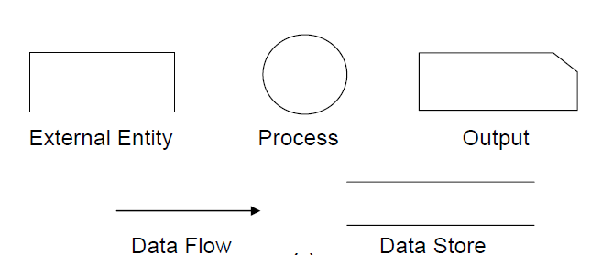

Fig 10.1: DFD Components

* **Entities** - Entities are source and destination of information data. Entities are represented by rectangles with their respective names.
* **Process** - Activities and action taken on the data are represented by Circle or Round- edged rectangles.
* **Data Storage** - There are two variants of data storage - it can either be represented as a rectangle with absence of both smaller sides or as an open-sided rectangle with only one side missing.
* **Data Flow** - Movement of data is shown by pointed arrows. Data movement is shown from the base of arrow as its source towards head of the arrow as destination.

### Importance of DFDs in a good software design

The main reason why the DFD technique is so popular is probably because of the fact that DFD is a very simple formalism – it is simple to understand and use. Starting with a set of high-level functions that a system performs, a DFD model hierarchically represents various sub-functions. In fact, any hierarchical model is simple to understand. Human mind is such that it can easily understand any hierarchical model of a system – because in a hierarchical model, starting with a very simple and abstract model of a system, different details of the system are slowly introduced through different hierarchies. The data flow diagramming technique also follows a very simple set of intuitive concepts and rules. DFD is an elegant modeling technique that turns out to be useful not only to represent the results of structured analysis of a software problem, but also for several other applications such as showing the flow of documents or items in an organization.

### Data Dictionary

A data dictionary lists all data items appearing in the DFD model of a system. The data items listed include all data flows and the contents of all data stores appearing on the DFDs in the DFD model of a system. A data dictionary lists the purpose of all data items and the definition of all composite data items in terms of their component data items. For example, a data dictionary entry may represent that the data **grossPay** consists of the components regularPay and overtimePay.

### grossPay = regularPay + overtimePay

For the smallest units of data items, the data dictionary lists their name and their type. Composite data items can be defined in terms of primitive data items using the following data definition operators:

**+**: denotes composition of two data items, e.g. **a+b** represents data a and **b**.

**[,,]**: represents selection, i.e. any one of the data items listed in the brackets can occur. For example, **[a,b]** represents either **a** occurs or **b** occurs.

**()**: the contents inside the bracket represent optional data which may or may not appear.

e.g. **a+(b)** represents either **a** occurs or **a+b** occurs.

**{}**: represents iterative data definition, e.g. **{name}5** represents five **name** data. **{name}\***

represents zero or more instances of **name** data.

**=**: represents equivalence, e.g. **a=b+c** means that **a** represents **b** and **c**.

**/* */**: Anything appearing within **/\*** and **\*/** is considered as a comment.

**Example 1:** Tic-Tac-Toe Computer Game

Tic-tac-toe is a computer game in which a human player and the computer make alternative moves on a 3×3 square. A move consists of marking previously unmarked square. The player who first places three consecutive marks along a straight line on the square (i.e. along a row, column, or diagonal) wins the game. As soon as either the human player or the computer wins, a message congratulating the winner should be displayed. If neither player manages to get three consecutive marks along a straight line, but all the squares on the board are filled up, then the game is drawn. The computer always tries to win a game.

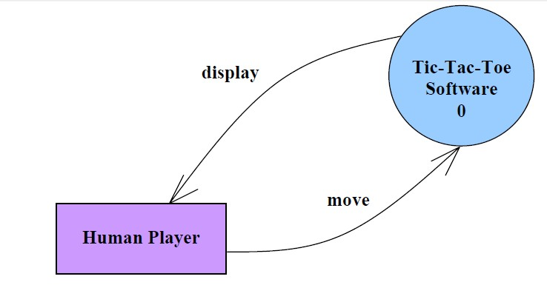

### (a)

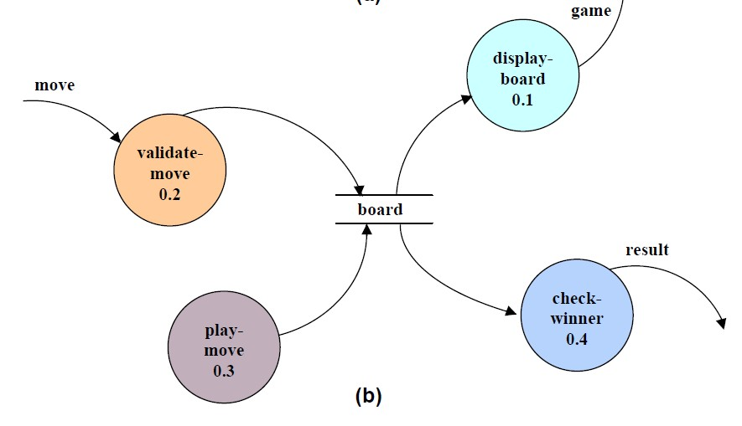

Fig 10.2 (a) Level 0 (b) Level 1 DFD for Tic-Tac-Toe game

It may be recalled that the DFD model of a system typically consists of several DFDs: level 0, level 1, etc. However, a single data dictionary should capture all the data appearing in all the DFDs constituting the model. Figure 10.2 represents the level 0 and level 1 DFDs for the tic-tac- toe game. The data dictionary for the model is given below.

### Data Dictionary for the DFD model in Example 1

move: integer /*number between 1 and 9 */ display: game+result

game: board board: {integer}9

result: [“computer won”, “human won” “draw”]

### Importance of Data Dictionary

A data dictionary plays a very important role in any software development process because of the following reasons:

* A data dictionary provides a standard terminology for all relevant data for use by the engineers working in a project. A consistent vocabulary for data items is very important, since in large projects different engineers of the project have a tendency to use different terms to refer to the same data, which unnecessary causes confusion.
* The data dictionary provides the analyst with a means to determine the definition of different data structures in terms of their component elements.

### Balancing a DFD

The data that flow into or out of a bubble must match the data flow at the next level of DFD. This is known as balancing a DFD. The concept of balancing a DFD has been illustrated in fig. 10.3. In the level 1 of the DFD, data items d1 and d3 flow out of the bubble 0.1 and the data item d2 flows into the bubble 0.1. In the next level, bubble 0.1 is decomposed. The decomposition is balanced, as d1 and d3 flow out of the level 2 diagram and d2 flows in.

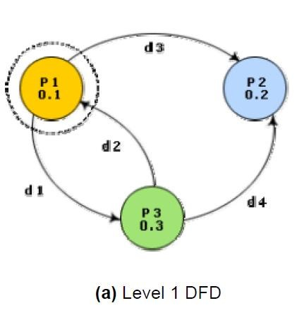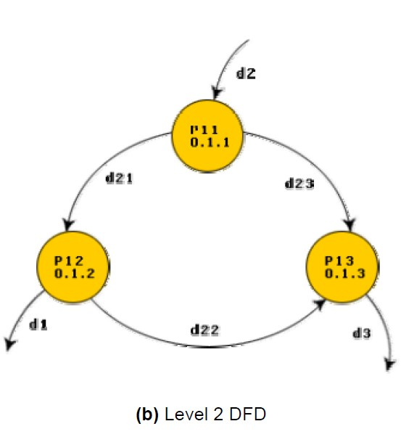

Fig. 10.3: An example showing balanced decomposition

### Context Diagram

The context diagram is the most abstract data flow representation of a system. It represents the entire system as a single bubble. This bubble is labeled according to the main function of the system. The various external entities with which the system interacts and the data flow occurring between the system and the external entities are also represented. The data input to the system and the data output from the system are represented as incoming and outgoing arrows. These data flow arrows should be annotated with the corresponding data names. The name ‘context diagram’ is well justified because it represents the context in which the system is to exist, i.e. the external entities who would interact with the system and the specific data items they would be supplying the system and the data items they would be receiving from the system. The context diagram is also called as the level 0 DFD.

To develop the context diagram of the system, it is required to analyze the SRS document to identify the different types of users who would be using the system and the kinds of data they would be inputting to the system and the data they would be receiving the system. Here, the term “users of the system” also includes the external systems which supply data to or receive data from the system.

The bubble in the context diagram is annotated with the name of the software system being developed (usually a noun). This is in contrast with the bubbles in all other levels which are annotated with verbs. This is expected since the purpose of the context diagram is to capture the context of the system rather than its functionality.

**Example 1:** RMS Calculating Software.

A software system called RMS calculating software would read three integral numbers from the user in the range of -1000 and +1000 and then determine the root mean square (rms) of the three input numbers and display it. In this example, the context diagram (fig. 10.4) is simple to draw. The system accepts three integers from the user and returns the result to him.

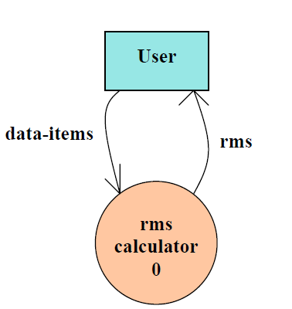

Fig. 10.4: Context Diagram

To develop the data flow model of a system, first the most abstract representation of the problem is to be worked out. The most abstract representation of the problem is also called the context diagram. After, developing the context diagram, the higher-level DFDs have to be developed.

**Context Diagram: -** This has been described earlier.

**Level 1 DFD: -** To develop the level 1 DFD, examine the high-level functional requirements. If there are between 3 to 7 high-level functional requirements, then these can be directly represented as bubbles in the level 1 DFD. We can then examine the input data to these functions and the data output by these functions and represent them appropriately in the diagram.

If a system has more than 7 high-level functional requirements, then some of the related requirements have to be combined and represented in the form of a bubble in the level 1 DFD. Such a bubble can be split in the lower DFD levels. If a system has less than three high-level functional requirements, then some of them need to be split into their sub-functions so that we have roughly about 5 to 7 bubbles on the diagram.

### Decomposition:-

Each bubble in the DFD represents a function performed by the system. The bubbles are decomposed into sub-functions at the successive levels of the DFD. Decomposition of a bubble is also known as factoring or exploding a bubble. Each bubble at any level of DFD is usually decomposed to anything between 3 to 7 bubbles. Too few bubbles at any level make that level

superfluous. For example, if a bubble is decomposed to just one bubble or two bubbles, then this decomposition becomes redundant. Also, too many bubbles, i.e. more than 7 bubbles at any level of a DFD makes the DFD model hard to understand. Decomposition of a bubble should be carried on until a level is reached at which the function of the bubble can be described using a simple algorithm.

### Numbering of Bubbles:-

It is necessary to number the different bubbles occurring in the DFD. These numbers help in uniquely identifying any bubble in the DFD by its bubble number. The bubble at the context level is usually assigned the number 0 to indicate that it is the 0 level DFD. Bubbles at level 1 are numbered, 0.1, 0.2, 0.3, etc, etc. When a bubble numbered x is decomposed, its children bubble are numbered x.1, x.2, x.3, etc. In this numbering scheme, by looking at the number of a bubble we can unambiguously determine its level, its ancestors, and its successors.

### Example:-

A supermarket needs to develop the following software to encourage regular customers. For this, the customer needs to supply his/her residence address, telephone number, and the driving license number. Each customer who registers for this scheme is assigned a unique customer number (CN) by the computer. A customer can present his CN to the check out staff when he makes any purchase. In this case, the value of his purchase is credited against his CN. At the end of each year, the supermarket intends to award surprise gifts to 10 customers who make the highest total purchase over the year. Also, it intends to award a 22 caret gold coin to every customer whose purchase exceeded Rs.10,000. The entries against the CN are the reset on the day of every year after the prize winners’ lists are generated.

The context diagram for this problem is shown in fig. 10.5, the level 1 DFD in fig. 10.6, and the level 2 DFD in fig. 10.7.

Fig. 10.5: Context diagram for supermarket problem

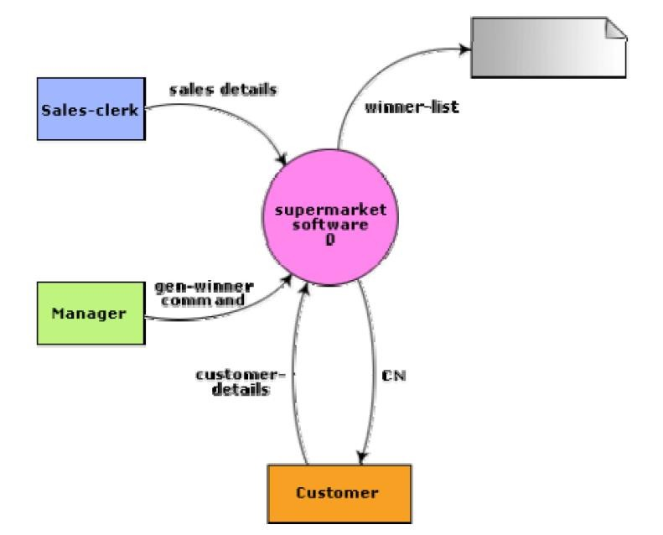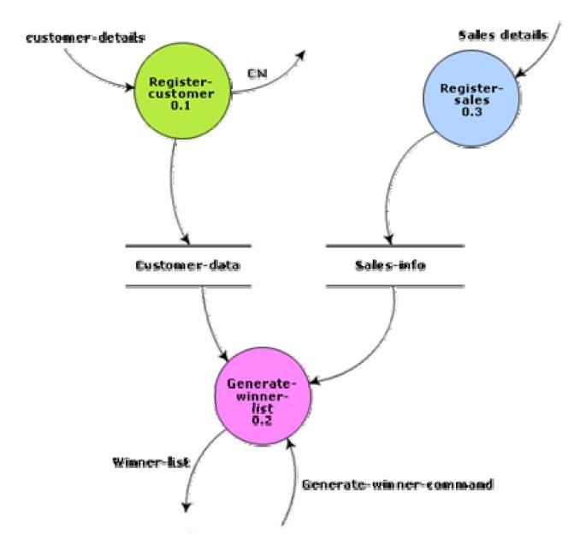

Fig. 10.6: Level 1 diagram for supermarket problem

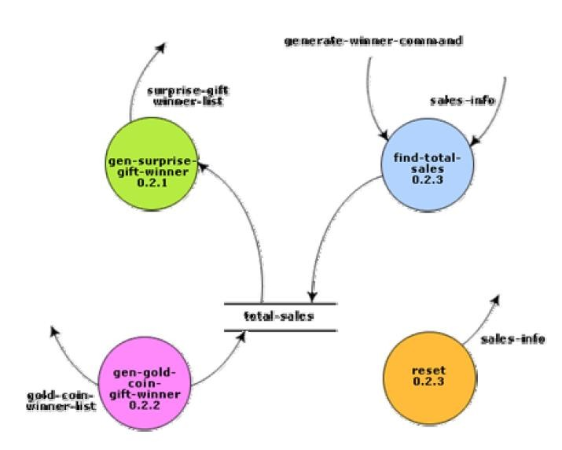

Fig. 10.7: Level 2 diagram for supermarket problem

**Example:** Trading-House Automation System (TAS).

The trading house wants us to develop a computerized system that would automate various book-keeping activities associated with its business. The following are the salient features of the system to be developed:

* + The trading house has a set of regular customers. The customers place orders with it for various kinds of commodities. The trading house maintains the names and addresses of its regular customers. Each of these regular customers should be assigned a unique customer identification number (CIN) by the computer. The customers quote their CIN on every order they place.
  + Once order is placed, as per current practice, the accounts department of the trading house first checks the credit-worthiness of the customer. The credit-worthiness of the customer is determined by analyzing the history of his payments to different bills sent to him in the past. After automation, this task has to be done by the computer.
  + If the customer is not credit-worthy, his orders are not processed any further and an appropriate order rejection message is generated for the customer.
  + If a customer is credit-worthy, the items that have been ordered are checked against a list of items that the trading house deals with. The items in the order which the trading house does not deal with, are not processed any further and an appropriate apology message for the customer for these items is generated.
  + The items in the customer’s order that the trading house deals with are checked for availability in the inventory. If the items are available in the inventory in the desired quantity, then
    - A bill with the forwarding address of the customer is printed.
    - A material issue slip is printed. The customer can produce this material issue slip at the store house and take delivery of the items.
    - Inventory data is adjusted to reflect the sale to the customer.

If any of the ordered items are not available in the inventory in sufficient quantity to satisfy the order, then these out-of-stock items along with the quantity ordered by the customer and the CIN are stored in a “pending-order” file for the further processing to be carried out when the purchase department issues the “generate indent” command.

* + The purchase department should be allowed to periodically issue commands to generate indents. When a command to generate indents is issued, the system should examine the “pending-order” file to determine the orders that are pending and determine the total quantity required for each of the items. It should find out the addresses of the vendors who supply these items by examining a file containing vendor details and then should print out indents to these vendors.
  + The system should also answer managerial queries regarding the statistics of different items sold over any given period of time and the corresponding quantity sold and the price realized.

The context diagram for the trading house automation problem is shown in fig. 10.8, and the level 1 DFD in fig. 10.9.

Fig. 10.8: Context diagram for TAS

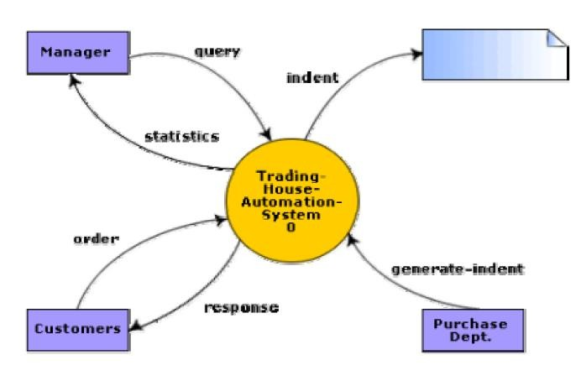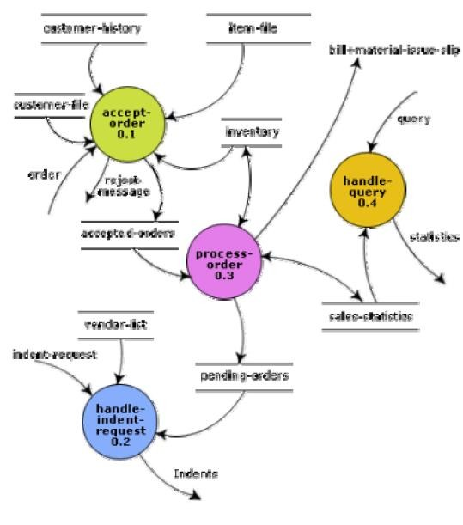

Fig. 10.9: Level 1 DFD for TAS

### Commonly made errors while constructing a DFD model

Although DFDs are simple to understand and draw, students and practitioners alike encounter similar types of problems while modelling software problems using DFDs. While learning from experience is powerful thing, it is an expensive pedagogical technique in the business world. It is therefore helpful to understand the different types of mistakes that users usually make while constructing the DFD model of systems.

* Many beginners commit the mistake of drawing more than one bubble in the context diagram. A context diagram should depict the system as a single bubble.
* Many beginners have external entities appearing at all levels of DFDs. All external entities interacting with the system should be represented only in the context diagram. The external entities should not appear at other levels of the DFD.
* It is a common oversight to have either too less or too many bubbles in a DFD. Only 3 to 7 bubbles per diagram should be allowed, i.e. each bubble should be decomposed to between 3 and 7 bubbles.
* Many beginners leave different levels of DFD unbalanced.
* A common mistake committed by many beginners while developing a DFD model is attempting to represent control information in a DFD. It is important to realize that a DFD is the data flow representation of a system, and it does not represent control information. For an example mistake of this kind:

Consider the following example. A book can be searched in the library catalog by inputting its name. If the book is available in the library, then the details of the book are displayed. If the book is not listed in the catalog, then an error message is generated. While generating the DFD model for this simple problem, many beginners commit the mistake of drawing an arrow (as shown in fig. 10.10) to indicate the error function is invoked after the search book. But, this is control information and should not be shown on the DFD.

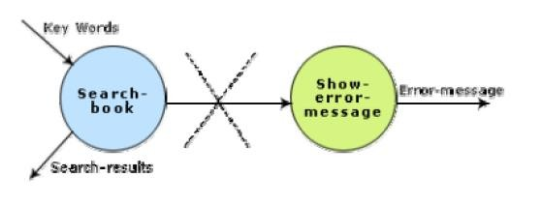

Fig. 10.10: Showing control information on a DFD - incorrect

* Another error is trying to represent when or in what order different functions (processes) are invoked and not representing the conditions under which different functions are invoked.
* If a bubble A invokes either the bubble B or the bubble C depending upon some conditions, we need only to represent the data that flows between bubbles A and B or bubbles A and C and not the conditions depending on which the two modules are invoked.
* A data store should be connected only to bubbles through data arrows. A data store cannot be connected to another data store or to an external entity.
* All the functionalities of the system must be captured by the DFD model. No function of the system specified in its SRS document should be overlooked.
* Only those functions of the system specified in the SRS document should be represented,
  1. the designer should not assume functionality of the system not specified by the SRS document and then try to represent them in the DFD.
* Improper or unsatisfactory data dictionary.
* The data and function names must be intuitive. Some students and even practicing engineers use symbolic data names such a, b, c, etc. Such names hinder understanding the DFD model.

### Shortcomings of a DFD model

DFD models suffer from several shortcomings. The important shortcomings of the DFD models are the following:

* ***DFDs leave ample scope to be imprecise*** - In the DFD model, the function performed by a bubble is judged from its label. However, a short label may not capture the entire functionality of a bubble. For example, a bubble named find-book-position has only intuitive meaning and does not specify several things, e.g. what happens when some input information are missing or are incorrect. Further, the find-book-position bubble may not convey anything regarding what happens when the required book is missing.
* ***Control aspects are not defined by a DFD***- For instance; the order in which inputs are consumed and outputs are produced by a bubble is not specified. A DFD model does not specify the order in which the different bubbles are executed. Representation of such aspects is very important for modeling real-time systems.
* The method of carrying out decomposition to arrive at the successive levels and the ultimate level to which decomposition is carried out are highly subjective and depend on the choice and judgment of the analyst. Due to this reason, even for the same problem, several alternative DFD representations are possible. Further, many times it is not possible to say which DFD representation is superior or preferable to another one.
* The data flow diagramming technique does not provide any specific guidance as to how exactly to decompose a given function into its sub-functions and we have to use subjective judgment to carry out decomposition.

**STRUCTURED DESIGN**

The aim of structured design is to transform the results of the structured analysis (i.e. a DFD representation) into a structure chart. Structured design provides two strategies to guide transformation of a DFD into a structure chart.

* Transform analysis
* Transaction analysis

Normally, one starts with the level 1 DFD, transforms it into module representation using either the transform or the transaction analysis and then proceeds towards the lower-level DFDs. At each level of transformation, it is important to first determine whether the transform or the transaction analysis is applicable to a particular DFD. These are discussed in the subsequent sub- sections.

### Structure Chart

A structure chart represents the software architecture, i.e. the various modules making up the system, the dependency (which module calls which other modules), and the parameters that are passed among the different modules. Hence, the structure chart representation can be easily implemented using some programming language. Since the main focus in a structure chart representation is on the module structure of the software and the interactions among different modules, the procedural aspects (e.g. how a particular functionality is achieved) are not represented.

The basic building blocks which are used to design structure charts are the following:

* **Rectangular boxes:** Represents a module.
* **Module invocation arrows:** Control is passed from on one module to another module in the direction of the connecting arrow.
* **Data flow arrows:** Arrows are annotated with data name; named data passes from one module to another module in the direction of the arrow.
* **Library modules:** Represented by a rectangle with double edges.
* **Selection:** Represented by a diamond symbol.
* **Repetition:** Represented by a loop around the control flow arrow.

### Structure Chart vs. Flow Chart

We are all familiar with the flow chart representation of a program. Flow chart is a convenient technique to represent the flow of control in a program. A structure chart differs from a flow chart in three principal ways:

* + It is usually difficult to identify the different modules of the software from its flow chart representation.
  + Data interchange among different modules is not represented in a flow chart.
  + Sequential ordering of tasks inherent in a flow chart is suppressed in a structure chart.

### Transform Analysis

Transform analysis identifies the primary functional components (modules) and the high level inputs and outputs for these components. The first step in transform analysis is to divide the DFD into 3 types of parts:

* + Input
  + Logical processing
  + Output

The input portion of the DFD includes processes that transform input data from physical (e.g. character from terminal) to logical forms (e.g. internal tables, lists, etc.). Each input portion is called an afferent branch.

The output portion of a DFD transforms output data from logical to physical form. Each output portion is called an efferent branch. The remaining portion of a DFD is called the central transform.

In the next step of transform analysis, the structure chart is derived by drawing one functional component for the ***central transform***, and the ***afferent*** and ***efferent*** branches.

These are drawn below a root module, which would invoke these modules. Identifying the highest level input and output transforms requires experience and skill. One possible approach is to trace the inputs until a bubble is found whose output cannot be deduced from its inputs alone. Processes which validate input or add information to them are not central transforms. Processes which sort input or filter data from it are. The first level structure chart is produced by representing each input and output unit as boxes and each central transform as a single box. In the third step of transform analysis, the structure chart is refined by adding sub-functions required by each of the high-level functional components. Many levels of functional components may be added. This process of breaking functional components into subcomponents is called factoring. Factoring includes adding read and write modules, error-handling modules, initialization and termination process, identifying customer modules, etc. The factoring process is continued until all bubbles in the DFD are represented in the structure chart.

**Example:** Structure chart for the RMS software

For this example, the context diagram was drawn earlier.

To draw the level 1 DFD (fig.11.1), from a cursory analysis of the problem description, we can see that there are four basic functions that the system needs to perform – accept the input numbers from the user, validate the numbers, calculate the root mean square of the input numbers and, then display the result.

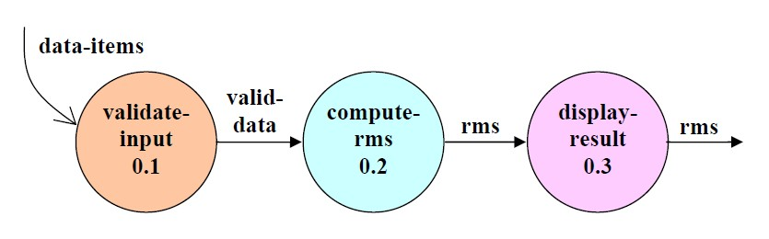

Fig. 11.1: Level 1 DFD

By observing the level 1 DFD, we identify the validate-input as the afferent branch and write- output as the efferent branch. The remaining portion (i.e. compute-rms) forms the central transform. By applying the step 2 and step 3 of transform analysis, we get the structure chart shown in fig.11.2.

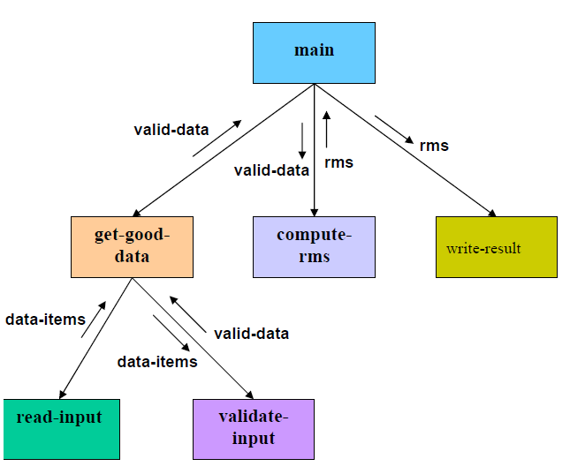

Fig. 11.2: Structure Chart

### Transaction Analysis

A transaction allows the user to perform some meaningful piece of work. Transaction analysis is useful while designing transaction processing programs. In a transaction-driven system, one of several possible paths through the DFD is traversed depending upon the input data item. This is in contrast to a transform centered system which is characterized by similar processing steps for each data item. Each different way in which input data is handled is a transaction. A simple way to identify a transaction is to check the input data. The number of bubbles on which the input data to the DFD are incident defines the number of transactions. However, some transaction may not require any input data. These transactions can be identified from the experience of solving a large number of examples.

For each identified transaction, trace the input data to the output. All the traversed bubbles belong to the transaction. These bubbles should be mapped to the same module on the structure chart. In the structure chart, draw a root module and below this module draw each identified transaction a module. Every transaction carries a tag, which identifies its type.

Transaction analysis uses this tag to divide the system into transaction modules and a transaction-center module.

The structure chart for the supermarket prize scheme software is shown in fig. 11.3.

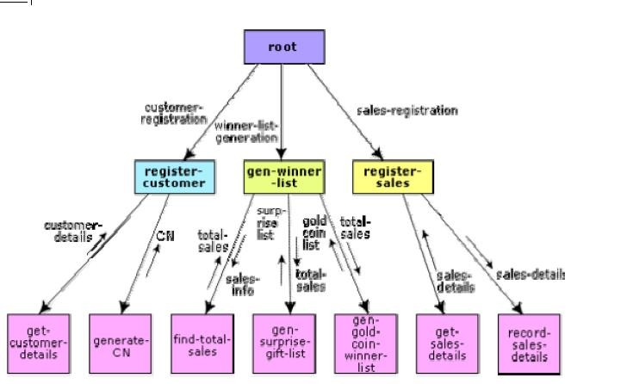

Fig. 11.3: Structure Chart for the supermarket prize scheme

**OBJECT MODELLING USING UML**

### Model

A model captures aspects important for some application while omitting (or abstracting) the rest. A model in the context of software development can be graphical, textual, mathematical, or program code-based. Models are very useful in documenting the design and analysis results. Models also facilitate the analysis and design procedures themselves. Graphical models are very popular because they are easy to understand and construct. UML is primarily a graphical modeling tool. However, it often requires text explanations to accompany the graphical models.

### Need for a model

An important reason behind constructing a model is that it helps manage complexity. Once models of a system have been constructed, these can be used for a variety of purposes during software development, including the following**:**

* Analysis
* Specification
* Code generation
* Design
* Visualize and understand the problem and the working of a system
* Testing, etc.

In all these applications, the UML models can not only be used to document the results but also to arrive at the results themselves. Since a model can be used for a variety of purposes, it is reasonable to expect that the model would vary depending on the purpose for which it is being constructed. For example, a model developed for initial analysis and specification should be very different from the one used for design. A model that is being used for analysis and specification would not show any of the design decisions that would be made later on during the design stage. On the other hand, a model used for design purposes should capture all the design decisions. Therefore, it is a good idea to explicitly mention the purpose for which a model has been developed, along with the model.

### Unified Modeling Language (UML)

UML, as the name implies, is a modeling language. It may be used to visualize, specify, construct, and document the artifacts of a software system. It provides a set of notations (e.g. rectangles, lines, ellipses, etc.) to create a visual model of the system. Like any other language, UML has its own syntax (symbols and sentence formation rules) and semantics (meanings of symbols and sentences). Also, we should clearly understand that UML is not a system design or development methodology, but can be used to document object-oriented and analysis results obtained using some methodology.

### Origin of UML

In the late 1980s and early 1990s, there was a proliferation of object-oriented design techniques and notations. Different software development houses were using different notations to document their object-oriented designs. These diverse notations used to give rise to a lot of confusion.

UML was developed to standardize the large number of object-oriented modeling notations that existed and were used extensively in the early 1990s. The principles ones in use were:

* + Object Management Technology [Rumbaugh 1991]
  + Booch’s methodology [Booch 1991]
  + Object-Oriented Software Engineering [Jacobson 1992]
  + Odell’s methodology [Odell 1992]
  + Shaler and Mellor methodology [Shaler 1992]

It is needless to say that UML has borrowed many concepts from these modeling techniques. Especially, concepts from the first three methodologies have been heavily drawn upon. UML was adopted by Object Management Group (OMG) as a *de facto* standard in 1997. OMG is an association of industries which tries to facilitate early formation of standards.

We shall see that UML contains an extensive set of notations and suggests construction of many types of diagrams. It has successfully been used to model both large and small problems. The elegance of UML, its adoption by OMG, and a strong industry backing have helped UML find widespread acceptance. UML is now being used in a large number of software development projects worldwide.

### UML Diagrams

UML can be used to construct nine different types of diagrams to capture five different views of a system. Just as a building can be modeled from several views (or perspectives) such as ventilation perspective, electrical perspective, lighting perspective, heating perspective, etc.; the different UML diagrams provide different perspectives of the software system to be developed and facilitate a comprehensive understanding of the system. Such models can be refined to get the actual implementation of the system.

The UML diagrams can capture the following five views of a system**:**

* User’s view
* Structural view
* Behavioral view
* Implementation view
* Environmental view

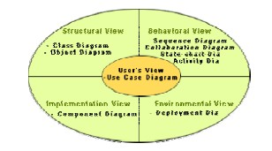

Fig. 12.1: Different types of diagrams and views supported in UML

**User’s view:** This view defines the functionalities (facilities) made available by the system to its users. The users’ view captures the external users’ view of the system in terms of the functionalities offered by the system. The users’ view is a black-box view of the system where the internal structure, the dynamic behavior of different system components, the implementation etc. are not visible. The users’ view is very different from all other views in the sense that it is a functional model compared to the object model of all other views. The users’ view can be considered as the central view and all other views are expected to conform to this view. This thinking is in fact the crux of any user centric development style.

**Structural view:** The structural view defines the kinds of objects (classes) important to the understanding of the working of a system and to its implementation. It also captures the

relationships among the classes (objects). The structural model is also called the static model, since the structure of a system does not change with time.

**Behavioral view:** The behavioral view captures how objects interact with each other to realize the system behavior. The system behavior captures the time-dependent (dynamic) behavior of the system.

**Implementation view:** This view captures the important components of the system and their dependencies.

**Environmental view:** This view models how the different components are implemented on different pieces of hardware.

**USE CASE DIAGRAM**

### Use Case Model

The use case model for any system consists of a set of “use cases”. Intuitively, use cases represent the different ways in which a system can be used by the users. A simple way to find all the use cases of a system is to ask the question: “What the users can do using the system?” Thus for the Library Information System (LIS), the use cases could be**:**

* + issue-book
  + query-book
  + return-book
  + create-member
  + add-book, etc

Use cases correspond to the high-level functional requirements. The use cases partition the system behavior into transactions, such that each transaction performs some useful action from the user’s point of view. To complete each transaction may involve either a single message or multiple message exchanges between the user and the system to complete.

Purpose of use cases

The purpose of a use case is to define a piece of coherent behavior without revealing the internal structure of the system. The use cases do not mention any specific algorithm to be used or the internal data representation, internal structure of the software, etc. A use case typically represents a sequence of interactions between the user and the system. These interactions consist of one mainline sequence. The mainline sequence represents the normal interaction between a user and the system. The mainline sequence is the most occurring sequence of interaction. For example, the mainline sequence of the withdraw cash use case supported by a bank ATM drawn, complete the transaction, and get the amount. Several variations to the main line sequence may also exist. Typically, a variation from the mainline sequence occurs when some specific conditions hold. For the bank ATM example, variations or alternate scenarios may occur, if the password is invalid or the amount to be withdrawn exceeds the amount balance. The variations are also called alternative paths. A use case can be viewed as a set of related scenarios tied together by a common goal. The mainline sequence and each of the variations are called scenarios or instances of the use case. Each scenario is a single path of user events and system activity through the use case.

### Representation of Use Cases

Use cases can be represented by drawing a use case diagram and writing an accompanying text elaborating the drawing. In the use case diagram, each use case is represented by an ellipse with the name of the use case written inside the ellipse. All the ellipses (i.e. use cases) of a system are enclosed within a rectangle which represents the system boundary. The name of the system being modeled (such as Library Information System) appears inside the rectangle.

The different users of the system are represented by using the stick person icon. Each stick person icon is normally referred to as an actor. An actor is a role played by a user with respect to the system use. It is possible that the same user may play the role of multiple actors. Each actor can participate in one or more use cases. The line connecting the actor and the use case is called the communication relationship. It indicates that the actor makes use of the functionality provided by the use case. Both the human users and the external systems can be represented by stick person icons. When a stick person icon represents an external system, it is annotated by the stereotype <<external system>>.

### Example 1:

Tic-Tac-Toe Computer Game

Tic-tac-toe is a computer game in which a human player and the computer make alternative moves on a 3×3 square. A move consists of marking previously unmarked square. The player who first places three consecutive marks along a straight line on the square (i.e. along a row, column, or diagonal) wins the game. As soon as either the human player or the computer wins, a message congratulating the winner should be displayed. If neither player manages to get three consecutive marks along a straight line, but all the squares on the board are filled up, then the game is drawn. The computer always tries to win a game.

The use case model for the Tic-tac-toe problem is shown in fig. 13.1. This software has only one use case “play move”. Note that the use case “get-user- move” is not used here. The name “get-user-move” would be inappropriate because the use cases should be named from the user’s perspective.

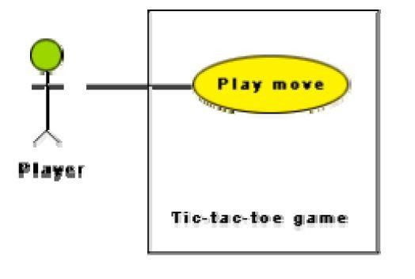

Fig. 13.1: Use case model for tic-tac-toe game

### Text Description

Each ellipse on the use case diagram should be accompanied by a text description. The text description should define the details of the interaction between the user and the computer and other aspects of the use case. It should include all the behavior associated with the use case in terms of the mainline sequence, different variations to the normal behavior, the system responses associated with the use case, the exceptional conditions that may occur in the behavior, etc. The behavior description is often written in a conversational style describing the interactions between the actor and the system. The text description may be informal, but some structuring is recommended. The following are some of the information which may be included in a use case text description in addition to the mainline sequence, and the alternative scenarios.

**Contact persons:** This section lists the personnel of the client organization with whom the use case was discussed, date and time of the meeting, etc.

**Actors:** In addition to identifying the actors, some information about actors using this use case which may help the implementation of the use case may be recorded.

**Pre-condition:** The preconditions would describe the state of the system before the use case execution starts.

**Post-condition:** This captures the state of the system after the use case has successfully completed.

**Non-functional requirements:** This could contain the important constraints for the design and implementation, such as platform and environment conditions, qualitative statements, response time requirements, etc.

**Exceptions, error situations:** This contains only the domain-related errors such as lack of user’s access rights, invalid entry in the input fields, etc. Obviously, errors that are not domain related, such as software errors, need not be discussed here.

**Sample dialogs:** These serve as examples illustrating the use case.

**Specific user interface requirements:** These contain specific requirements for the user interface of the use case. For example, it may contain forms to be used, screen shots, interaction style, etc.

**Document references:** This part contains references to specific domain-related documents which may be useful to understand the system operation

### Example 2:

A supermarket needs to develop the following software to encourage regular customers. For this, the customer needs to supply his/her residence address, telephone number, and the driving license number. Each customer who registers for this scheme is assigned a unique customer number (CN) by the computer. A customer can present his CN to the checkout staff when he makes any purchase. In this case, the value of his purchase is credited against his CN. At the end of

each year, the supermarket intends to award surprise gifts to 10 customers who make the highest total purchase over the year. Also, it intends to award a 22 caret gold coin to every customer whose purchase exceeded Rs.10,000. The entries against the CN are the reset on the day of every year after the prize winners’ lists are generated.

The use case model for the Supermarket Prize Scheme is shown in fig. 13.2. As discussed earlier, the use cases correspond to the high-level functional requirements. From the problem description, we can identify three use cases: “register-customer”, “register-sales”, and “select- winners”. As a sample, the text description for the use case “register-customer” is shown.

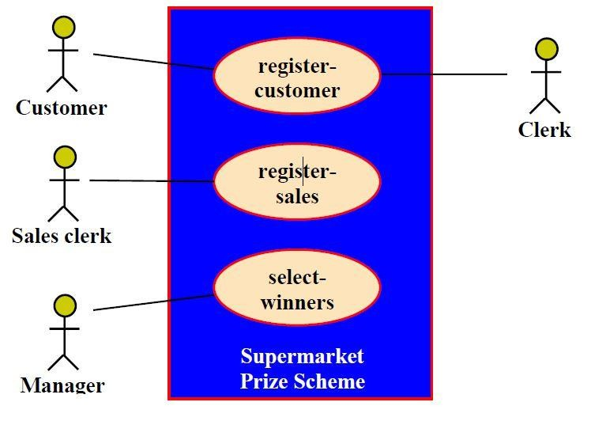

Fig. 13.2 Use case model for Supermarket Prize Scheme

**Text description**

**U1:** register-customer: Using this use case, the customer can register himself by providing the necessary details.

### Scenario 1: Mainline sequence

* + 1. Customer: select register customer option.
    2. System: display prompt to enter name, address, and telephone number. Customer: enter the necessary values.

4. System: display the generated id and the message that the customer has been successfully registered.

**Scenario 2:** at step 4 of mainline sequence

1. System: displays the message that the customer has already registered.

**Scenario 2:** at step 4 of mainline sequence

1**.** System: displays the message that some input information has not been entered. The system displays a prompt to enter the missing value.

The description for other use cases is written in a similar fashion.

### Utility of use case diagrams

From use case diagram, it is obvious that the utility of the use cases are represented by ellipses. They along with the accompanying text description serve as a type of requirements specification of the system and form the core model to which all other models must conform. But, what about the actors (stick person icons)? One possible use of identifying the different types of users (actors) is in identifying and implementing a security mechanism through a login system, so that each actor can involve only those functionalities to which he is entitled to. Another possible use is in preparing the documentation (e.g. users’ manual) targeted at each category of user. Further, actors help in identifying the use cases and understanding the exact functioning of the system.

### Factoring of use cases

It is often desirable to factor use cases into component use cases. Actually, factoring of use cases are required under two situations. First, complex use cases need to be factored into simpler use cases. This would not only make the behavior associated with the use case much more comprehensible, but also make the corresponding interaction diagrams more tractable. Without decomposition, the interaction diagrams for complex use cases may become too large to be accommodated on a single sized (A4) paper. Secondly, use cases need to be factored whenever there is common behavior across different use cases. Factoring would make it possible to define such behavior only once and reuse it whenever required. It is desirable to factor out common usage such as error handling from a set of use cases. This makes analysis of the class design much simpler and elegant. However, a word of caution here. Factoring of use cases should not be done except for achieving the above two objectives. From the design point of view, it is not advantageous to break up a use case into many smaller parts just for the sake of it.

UML offers three mechanisms for factoring of use cases as follows:

### 1. Generalization

Use case generalization can be used when one use case that is similar to another, but does something slightly differently or something more. Generalization works the same way with use cases as it does with classes. The child use case inherits the behavior and meaning of the parent use case. The notation is the same too (as shown in fig. 13.3). It is important to remember that the base and the derived use cases are separate use cases and should have separate text descriptions.

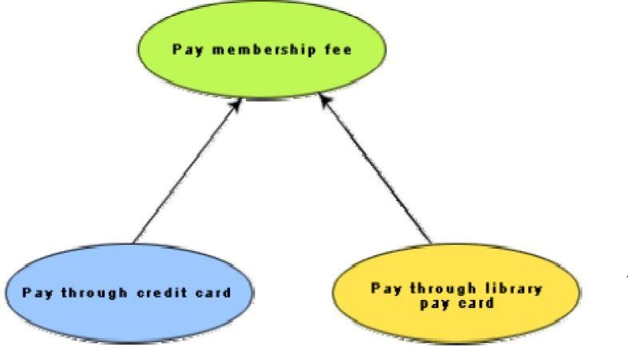

Fig. 13.3: Representation of use case generalization

### Includes

The *includes* relationship in the older versions of UML (prior to UML 1.1) was known as the uses relationship. The *includes* relationship involves one use case including the behavior of another use case in its sequence of events and actions. The *includes* relationship occurs when a chunk of behavior that is similar across a number of use cases. The factoring of such behavior will help in not repeating the specification and implementation across different use cases. Thus, the *includes* relationship explores the issue of reuse by factoring out the commonality across use cases. It can also be gainfully employed to decompose a large and complex use cases into more manageable parts. As shown in fig. 13.4 the *includes* relationship is represented using a predefined stereotype

<<include>>.In the *includes* relationship, a base use case compulsorily and automatically

includes the behavior of the common use cases. As shown in example fig. 13.5, issue- book and renew-book both include check-reservation use case. The base use case may include several use cases. In such cases, it may interleave their associated common use cases together. The common use case becomes a separate use case and the independent text description should be provided for it.

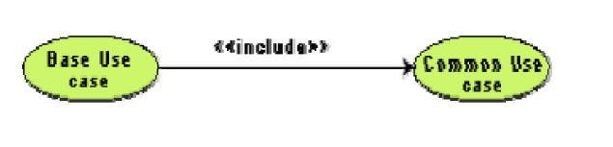

Fig. 13.4 Representation of use case inclusion

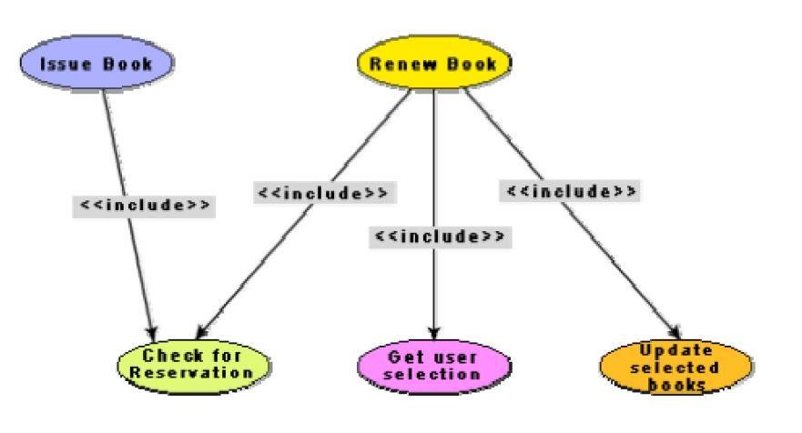

Fig. 13.5: Example use case inclusion

**Extends**

The main idea behind the *extends* relationship among the use cases is that it allows you to show optional system behavior. An optional system behavior is extended only under certain conditions. This relationship among use cases is also predefined as a stereotype as shown in fig. 13.6. The *extends* relationship is similar to generalization. But unlike generalization, the extending use case can add additional behavior only at an extension point only when certain

conditions are satisfied. The extension points are points within the use case where variation to the mainline (normal) action sequence may occur. The *extends* relationship is normally used to capture alternate paths or scenarios.

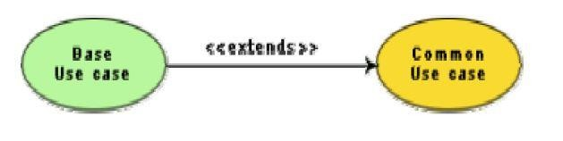

Fig. 13.6: Example use case extension

### Organization of use cases

When the use cases are factored, they are organized hierarchically. The high-level use cases are refined into a set of smaller and more refined use cases as shown in fig. 13.7. Top-level use cases are super-ordinate to the refined use cases. The refined use cases are sub-ordinate to the top-level use cases. Note that only the complex use cases should be decomposed and organized in a hierarchy. It is not necessary to decompose simple use cases. The functionality of the super- ordinate use cases is traceable to their sub-ordinate use cases. Thus, the functionality provided by the super-ordinate use cases is composite of the functionality of the sub-ordinate use cases. In the highest level of the use case model, only the fundamental use cases are shown. The focus is on the application context. Therefore, this level is also referred to as the context diagram. In the context diagram, the system limits are emphasized. In the top-level diagram, only those use cases with which external users of the system. The subsystem-level use cases specify the services offered by the subsystems. Any number of levels involving the subsystems may be utilized. In the lowest level of the use case hierarchy, the class-level use cases specify the functional fragments or operations offered by the classes.

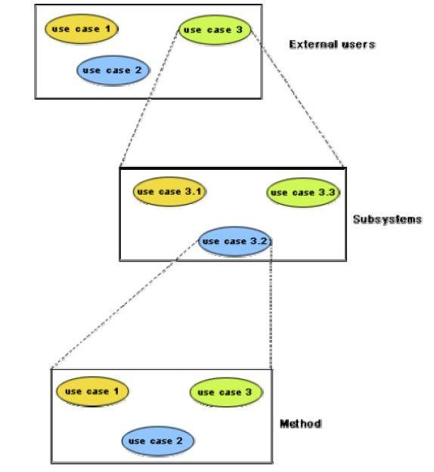

Fig. 13.7: Hierarchical organization of use cases

# CLASS DIAGRAMS

## 

A class diagram describes the static structure of a system. It shows how a system is structured rather than how it behaves. The static structure of a system comprises of a number of class diagrams and their dependencies. The main constituents of a class diagram are classes and their relationships: generalization, aggregation, association, and various kinds of dependencies.

**Classes**

The classes represent entities with common features, i.e. attributes and operations. Classes are represented as solid outline rectangles with compartments. Classes have a mandatory name compartment where the name is written centered in boldface. The class name is usually written using mixed case convention and begins with an uppercase. The class names are usually chosen to be singular nouns. Classes have optional attributes and operations compartments. A class may appear on several diagrams. Its attributes and operations are suppressed on all but one diagram.

**Attributes**

An attribute is a named property of a class. It represents the kind of data that an object might contain. Attributes are listed with their names, and may optionally contain specification of their type, an initial value, and constraints. The type of the attribute is written by appending a colon and the type name after the attribute name. Typically, the first letter of a class name is a small letter. An example for an attribute is given.

**bookName : String**

**Operation**

Operation is the implementation of a service that can be requested from any object of the class to affect behaviour. An object’s data or state can be changed by invoking an operation of the object. A class may have any number of operations or no operation at all. Typically, the first letter of an operation name is a small letter. Abstract operations are written in italics. The parameters of an operation (if any), may have a kind specified, which may be ‘in’, ‘out’ or ‘inout’. An operation may have a return type consisting of a single return type expression. An example for an operation is given.

**issueBook(in bookName):Boolean**

### Association

Associations are needed to enable objects to communicate with each other. An association describes a connection between classes. The association relation between two objects is called object connection or link. Links are instances of associations. A link is a physical or conceptual connection between object instances. For example, suppose Amit has borrowed the book Graph Theory. Here,

borrowed is the connection between the objects Amit and Graph Theory book. Mathematically, a link can be considered to be a tuple, i.e. an ordered list of object instances. An association describes a group of links with a common structure and common semantics. For example, consider the statement that Library Member borrows Books. Here, borrows is the association between the class LibraryMember and the class Book. Usually, an association is a binary relation (between two classes). However, three or more different classes can be involved in an association. A class can have an association relationship with itself (called recursive association). In this case, it is usually assumed that two different objects of the class are linked by the association relationship. Association between two classes is represented by drawing a straight line between the concerned classes.

Fig. 14.1 illustrates the graphical representation of the association relation. The name of the association is written alongside the association line. An arrowhead may be placed on the association line to indicate the reading direction of the association. The arrowhead should not be misunderstood to be indicating the direction of a pointer implementing an association. On each side of the association relation, the multiplicity is noted as an individual number or as a value range. The multiplicity indicates how many instances of one class are associated with each other. Value ranges of multiplicity are noted by specifying the minimum and maximum value, separated by two dots, e.g.

* 1. An asterisk is a wild card and means many (zero or more). The association of fig. 14.1 should be read as “Many books may be borrowed by a Library Member”. Observe that associations (and links) appear as verbs in the problem statement.

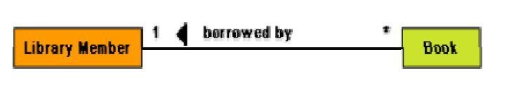

Fig. 14.1: Association between two classes

Associations are usually realized by assigning appropriate reference attributes to the classes involved. Thus, associations can be implemented using pointers from one object class to another. Links and associations can also be implemented by using a separate class that stores which objects of a class are linked to which objects of another class. Some CASE tools use the role names of the association relation for the corresponding automatically generated attribute.

### Aggregation

Aggregation is a special type of association where the involved classes represent a whole-part relationship. The aggregate takes the responsibility of forwarding messages to the appropriate parts. Thus, the aggregate takes the responsibility of delegation and leadership. When an instance of one object contains instances of some other objects, then aggregation (or composition) relationship exists between the composite object and the component object. Aggregation is represented by the diamond

symbol at the composite end of a relationship. The number of instances of the component class aggregated can also be shown as in fig. 14.2

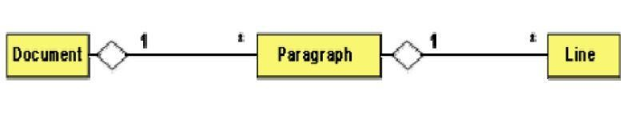

Fig. 14.2: Representation of aggregation

Aggregation relationship cannot be reflexive (i.e. recursive). That is, an object cannot contain objects of the same class as itself. Also, the aggregation relation is not symmetric. That is, two classes A and B cannot contain instances of each other. However, the aggregation relationship can be transitive. In this case, aggregation may consist of an arbitrary number of levels.

### Composition

Composition is a stricter form of aggregation, in which the parts are existence-dependent on the whole. This means that the life of the parts closely ties to the life of the whole. When the whole is created, the parts are created and when the whole is destroyed, the parts are destroyed. A typical example of composition is an invoice object with invoice items. As soon as the invoice object is created, all the invoice items in it are created and as soon as the invoice object is destroyed, all invoice items in it are also destroyed. The composition relationship is represented as a filled diamond drawn at the composite-end. An example of the composition relationship is shown in fig. 14.3

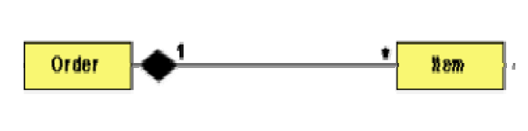

Fig 14.3: Representation of composition

### Association vs. Aggregation vs. Composition

* + - Association is the most general (m:n) relationship. Aggregation is a stronger relationship where one is a part of the other. Composition is even stronger than aggregation, ties the lifecycle of the part and the whole together.
    - Association relationship can be reflexive (objects can have relation to itself), but aggregation cannot be reflexive. Moreover, aggregation is anti-symmetric (If B is a part of A, A cannot be a part of B).
    - Composition has the property of exclusive aggregation i.e. an object can be a part of only one composite at a time. For example, a **Frame** belongs to exactly one **Window**

whereas in simple aggregation, a part may be shared by several objects. For example, a **Wall** may be a part of one or more **Room** objects.

* + - In addition, in composition, the whole has the responsibility for the disposition of all its parts, i.e. for their creation and destruction.
      * in general, the lifetime of parts and composite coincides
      * parts with non-fixed multiplicity may be created after composite itself
      * parts might be explicitly removed before the death of the composite

For example, when a **Frame** is created, it has to be attached to an enclosing **Window**. Similarly, when the **Window** is destroyed, it must in turn destroy its **Frame** parts.

### Inheritance vs. Aggregation/Composition

* Inheritance describes *‘is a’ / ‘is a kind of’* relationship between classes (base class - derived class) whereas aggregation describes *‘has a’* relationship between classes. Inheritance means that the object of the derived class inherits the properties of the base class; aggregation means that the object of the whole has objects of the part. For example, the relation “cash payment *is a kind of* payment” is modeled using inheritance; “purchase order has a few items” is modeled using aggregation.
* Inheritance is used to model a “generic-specific” relationship between classes whereas aggregation/composition is used to model a “whole-part” relationship between classes.
* Inheritance means that the objects of the subclass can be used anywhere the super class may appear, but not the reverse; i.e. wherever we could use instances of ‘payment’ in the system, we could substitute it with instances of ‘cash payment’, but the reverse cannot be done.
* Inheritance is defined statically. It cannot be changed at run-time. Aggregation is defined dynamically and can be changed at run-time. Aggregation is used when the type of the object can change over time.

For example, consider this situation in a business system. A **BusinessPartner** might be a **Customer** or a **Supplier** or both. Initially we might be tempted to model it as in Fig 14.4(a). But in fact, during its lifetime, a business partner might become a customer as well as a supplier, or it might change from one to the other. In such cases, we prefer aggregation instead (see Fig 14.4(b). Here, a business partner is a **Customer** if it has an aggregated **Customer** object, a **Supplier** if it has an aggregated **Supplier** object and a "C**ustomer_Supplier**" if it has both. Here, we have only two types. Hence, we are able to model it as inheritance. But what if there were several different types and combinations thereof? The inheritance tree would be absolutely incomprehensible.

Also, the aggregation model allows the possibility for a business partner to be neither - i.e. has neither a customer nor a supplier object aggregated with it.

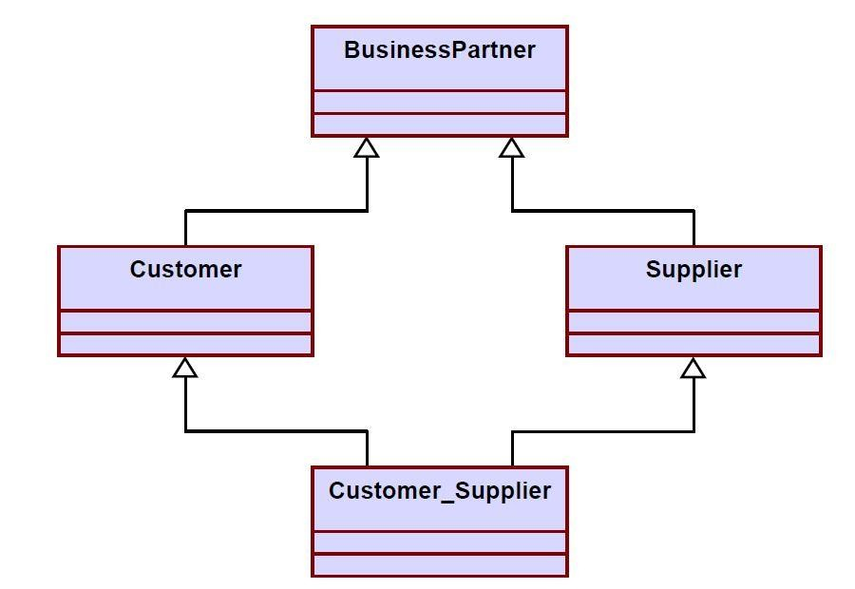

Fig. 14.4 a) Representation of **BusinessPartner, Customer, Supplier** relationship using inheritance

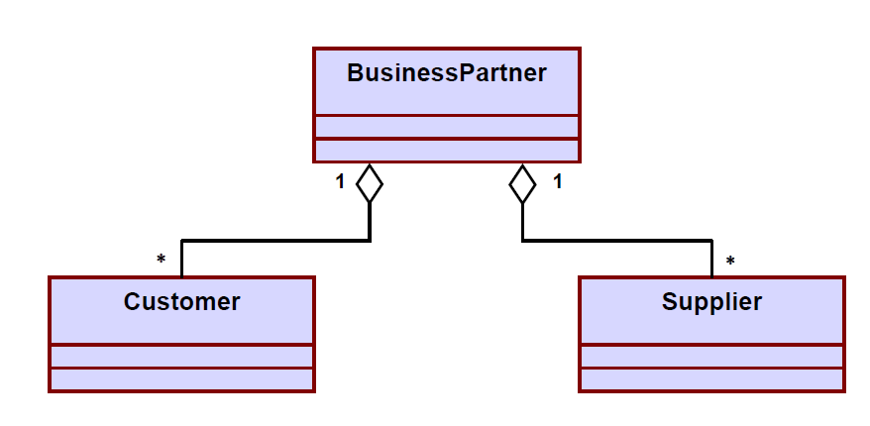

Fig. 14.4 b) Representation of **BusinessPartner, Customer, Supplier** relationship using aggregation

* The advantage of aggregation is the integrity of encapsulation. The operations of an object are the interfaces of other objects which imply low implementation dependencies. The significant disadvantage of aggregation is the increase in the number of objects and their relationships. On the other hand, inheritance allows for an easy way to modify implementation for reusability. But the significant disadvantage is that it breaks encapsulation, which implies implementation dependence.

**INTERACTION DIAGRAMS**

Interaction diagrams are models that describe how group of objects collaborate to realize some behavior. Typically, each interaction diagram realizes the behavior of a single use case. An interaction diagram shows a number of example objects and the messages that are passed between the objects within the use case.

There are two kinds of interaction diagrams: sequence diagrams and collaboration diagrams. These two diagrams are equivalent in the sense that any one diagram can be derived automatically from the other. However, they are both useful. These two actually portray different perspectives of behavior of the system and different types of inferences can be drawn from them. The interaction diagrams can be considered as a major tool in the design methodology.

**Sequence Diagram**

A sequence diagram shows interaction among objects as a two dimensional chart. The chart is read from top to bottom. The objects participating in the interaction are shown at the top of the chart as boxes attached to a vertical dashed line. Inside the box the name of the object is written with a colon separating it from the name of the class and both the name of the object and the class are underlined. The objects appearing at the top signify that the object already existed when the use case execution was initiated. However, if some object is created during the execution of the use case and participates in the interaction (e.g. a method call), then the object should be shown at the appropriate place on the diagram where it is created. The vertical dashed line is called the object’s lifeline. The lifeline indicates the existence of the object at any particular point of time. The rectangle drawn on the lifetime is called the activation symbol and indicates that the object is active as long as the rectangle exists. Each message is indicated as an arrow between the life line of two objects. The messages are shown in chronological order from the top to the bottom. That is, reading the diagram from the top to the bottom would show the sequence in which the messages occur. Each message is labeled with the message name. Some control information can also be included. Two types of control information are particularly valuable.

* A condition (e.g. [invalid]) indicates that a message is sent, only if the condition is true.
* An iteration marker shows the message is sent many times to multiple receiver objects as would happen when a collection or the elements of an array are being iterated. The basis of the iteration can also be indicated e.g. [for every book object].

The sequence diagram for the book renewal use case for the Library Automation Software is shown in fig. 15.1. The development of the sequence diagram in the development methodology would help us in determining the responsibilities of the different classes; i.e. what methods should be supported by each class.

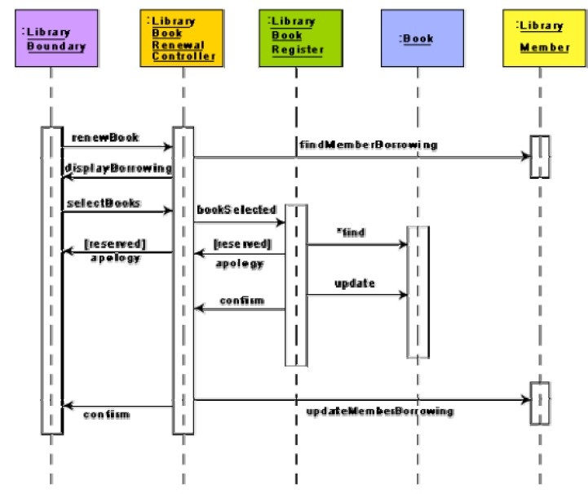

Fig. 15.1: Sequence diagram for the renew book use case

**Collaboration Diagram**

A collaboration diagram shows both structural and behavioral aspects explicitly. This is unlike a sequence diagram which shows only the behavioral aspects. The structural aspect of a collaboration diagram consists of objects and the links existing between them. In this diagram, an object is also called a collaborator. The behavioral aspect is described by the set of messages exchanged among the different collaborators. The link between objects is shown as a solid line and can be used to send messages between two objects. The message is shown as a labeled arrow placed near the link. Messages are prefixed with sequence numbers because they are only way to describe the relative sequencing of the messages in this diagram. The collaboration diagram for the example of fig. 15.1 is shown in fig. 15.2. The use of the collaboration diagrams in our development process would be to help us to determine which classes are associated with which other classes.

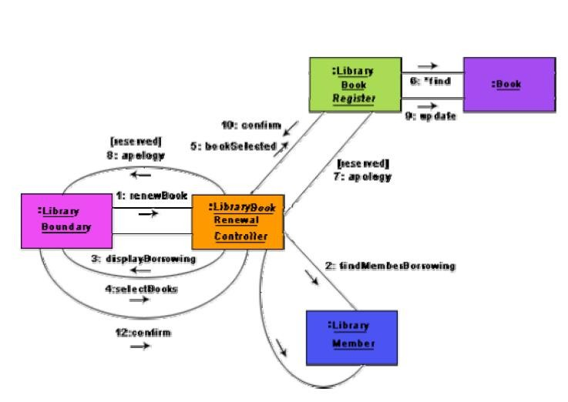

Fig 15.2: Collaboration diagram for the renew book use case

**ACTIVITY AND STATE CHART DIAGRAM**

The activity diagram is possibly one modeling element which was not present in any of the predecessors of UML. No such diagrams were present either in the works of Booch, Jacobson, or Rumbaugh. It is possibly based on the event diagram of Odell [1992] through the notation is very different from that used by Odell. The activity diagram focuses on representing activities or chunks of processing which may or may not correspond to the methods of classes. An activity is a state with an internal action and one or more outgoing transitions which automatically follow the termination of the internal activity. If an activity has more than one outgoing transitions, then these must be identified through conditions. An interesting feature of the activity diagrams is the swim lanes. Swim lanes enable you to group activities based on who is performing them, e.g. academic department vs. hostel office. Thus swim lanes subdivide activities based on the responsibilities of some components. The activities in a swim lane can be assigned to some model elements, e.g. classes or some component, etc.

Activity diagrams are normally employed in business process modeling. This is carried out during the initial stages of requirements analysis and specification. Activity diagrams can be very useful to understand complex processing activities involving many components. Later these diagrams can be used to develop interaction diagrams which help to allocate activities (responsibilities) to classes.

The student admission process in a university is shown as an activity diagram in fig. 16.1. This shows the part played by different components of the Institute in the admission procedure. After the fees are received at the account section, parallel activities start at the hostel office, hospital, and the Department. After all these activities complete (this synchronization is represented as a horizontal line), the identity card can be issued to a student by the Academic section.

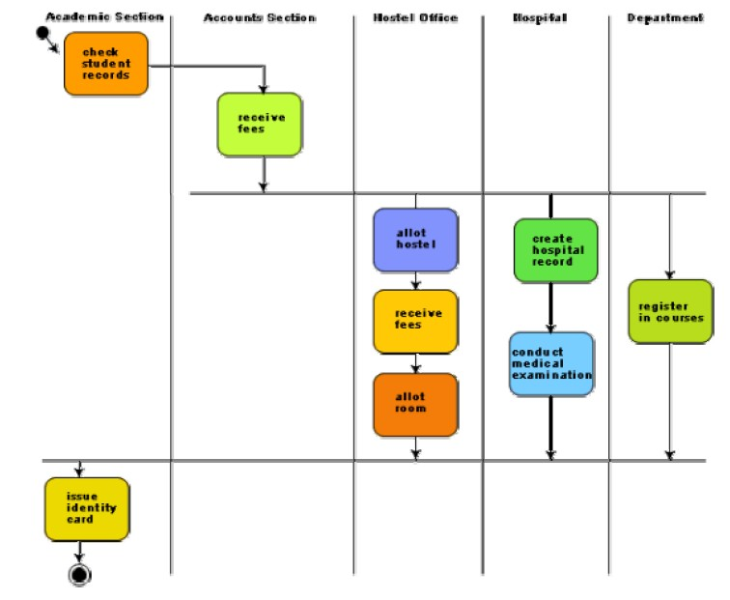

Fig. 16.1: Activity diagram for student admission procedure at a university

### Activity diagrams vs. procedural flow charts

Activity diagrams are similar to the procedural flow charts. The difference is that activity diagrams support description of parallel activities and synchronization aspects involved in different activities.

### STATE CHART DIAGRAM

A state chart diagram is normally used to model how the state of an object changes in its lifetime. State chart diagrams are good at describing how the behavior of an object changes across several use case executions. However, if we are interested in modeling some behavior that involves several objects collaborating with each other, state chart diagram is not appropriate. State chart diagrams are based on the finite state machine (FSM) formalism.

A FSM consists of a finite number of states corresponding to those of the object being modeled. The object undergoes state changes when specific events occur. The FSM formalism existed long before the object-oriented technology and has been used for a wide variety of applications. Apart from modeling, it has even been used in theoretical computer science as a generator for regular languages.

A major disadvantage of the FSM formalism is the state explosion problem. The number of states becomes too many and the model too complex when used to model practical systems. This problem is overcome in UML by using state charts. The state chart formalism was proposed by David Harel [1990]. A state chart is a hierarchical model of a system and introduces the concept of a composite state (also called nested state).

Actions are associated with transitions and are considered to be processes that occur quickly and are not interruptible. Activities are associated with states and can take longer. An activity can be interrupted by an event.

The basic elements of the state chart diagram are as follows:

* + **Initial state-** This is represented as a filled circle.
  + **Final state-** This is represented by a filled circle inside a larger circle.
  + **State-** These are represented by rectangles with rounded corners.
  + **Transition-** A transition is shown as an arrow between two states. Normally, the name of the event which causes the transition is places alongside the arrow. A guard to the transition can also be assigned. A guard is a Boolean logic condition. The transition can take place only if the grade evaluates to true. The syntax for the label of the transition is shown in 3 parts: event [guard]/action.

An example state chart for the order object of the Trade House Automation software is shown in fig. 16.2.

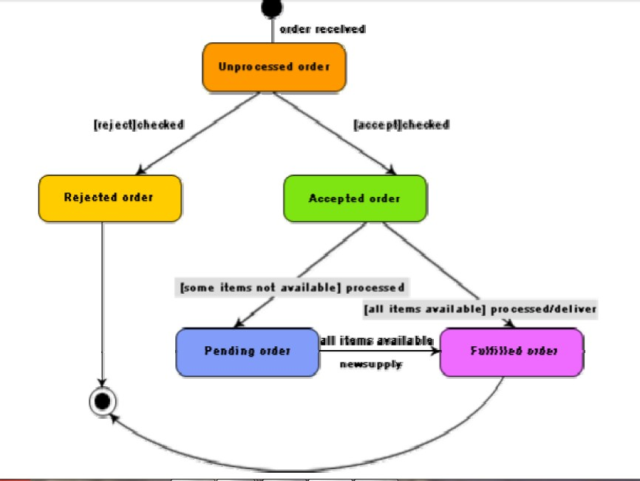

Fig. 16.2: State chart diagram for an order object

### Activity diagram vs. State chart diagram

* + Both activity and state chart diagrams model the dynamic behavior of the system. Activity diagram is essentially a flowchart showing flow of control from activity to activity. A state chart diagram shows a state machine emphasizing the flow of control from state to state.
  + An activity diagram is a special case of a state chart diagram in which all or most of the states are activity states and all or most of the transitions are triggered by completion of activities in the source state (An activity is an ongoing non-atomic execution within a state machine).
  + Activity diagrams may stand alone to visualize, specify, and document the dynamics of a society of objects or they may be used to model the flow of control of an operation. State chart diagrams may be attached to classes, use cases, or entire systems in order to visualize, specify, and document the dynamics of an individual object.